|  |  |
| --- | --- |
|  |  |

AT&T Platform & mS Architecture

How AJSC6 platform & API One Platform Patterns shaping our mS Development

5/23/2017

AT&T

Shared Platforms & Engineering – Applications Engineering

**REVISION HISTORY**

|  |  |  |  |
| --- | --- | --- | --- |
| **Document Version No.** | **Date** | **Author** | **Description** |
| 0.1 | 04/20/2017 | Nazmul Huq | Initial Draft |
| 0.2 | 04/23/2017 | Nazmul Huq | * Adding more Payment Example * Adding ‘Seed Template’ information |
| 0.3 | 04/30/2017 | Nazmul Huq | * Included API One Platform Patterns and mS implementation |
| 0.4 | 05/04/2017 | Nazmul Huq | * Bronze Pattern Note Updated * Naming Standards Updated |
| 0.5 | 05/15/2017 | Nazmul Huq | * Added document links |
|  | 05/23/2017 | Nazmul Huq | * Updated section 2 * Added SRE doc link * Updated Section 5 |
| 1.0 | 6/19/2017 | Colleen Casper | * Remove Draft Status and baseline document |
|  | 7/18/2017 | Nazmul Huq | * Naming diagram upgraded |

**Table of Contents**

REVISION HISTORY 1

1 Objective 4

1.1 Scope of the Document 5

2 Business Domain Knowledge for mS Development 5

3 Software Architecture and mS 7

3.1 SoR and Business Domain Capability 11

3.1.1 Decomposition of a Domain 12

3.1.2 Example Store-Front Application 56

3.1.3 Shared Data across Micro Services and SoR 58

3.2 Integration mSs (Integration Tier) 60

3.3 Presentation mSs (Presentation Tiers) 61

4 SoR mS and Bounded Context 61

4.1 Solution Space, new mS Design 63

5 Patterns 5/6 and mS 67

6 mS Naming, Implementation and AJSC6 Platform 68

6.1 AJSC6 and mS 68

6.2 Framework Features 69

6.3 AJSC6 Platform Seed Templates 69

a) AJSC-M2E Templates 72

b) AJSC-NONMODELED Templates 73

c) AJSC-MAF Template 73

6.4 CSI DB, CSI Dashboard, CS BOBPM DB 73

6.5 Common Data Model Restructuring (CDMR) 73

6.5.1 Service Namespace Change 74

6.5.2 Adapter Schema structure change 74

6.6 Modeled SOAP and REST API (M2E) as mSs 75

6.7 mSNaming Conventions 76

7 mS Design Principles, Patterns & Anti Patterns 80

7.1 Principles Definition 80

7.1.1 Domain Driven Design 83

7.1.2 Right Sizing of an Api 84

7.1.3 Bounded Context 84

7.2 mS Patterns 85

7.2.1 Presentation mS 85

7.2.2 Integration mS 85

7.2.3 Legacy Enabling mS 86

7.2.4 SoR mS 87

7.2.5 Cache Population 88

7.2.6 Cross-Context/Domain Dependencies 88

7.3 mS Anti Patterns/Pitfalls 89

7.3.1 Cohesion Chaos 89

7.3.2 Layered service architecture 89

7.3.3 Relying on Consumer Sign-Off 90

7.3.4 Data Driven Migration 90

7.3.5 Unknown Caller/Debugging Hell Too Many Data Migration 91

7.3.6 Synchronous World/Timeout 91

7.3.7 Timeout/Circuit Breaker Pattern 92

7.3.8 Shared Data and mS 93

7.3.9 Reach-in Reporting 94

8 Resiliency and mS Architecture 96

9 Software Packaging, Delivery and Deployment 97

9.1 mS and Containerization using Docker 98

9.2 Container Management & Kubernetes 101

9.3 Summary Steps for Build and Deploy 102

10 Glossary 103

Appendix-A (AJSC 6, Docker & K8S Resource Links) 103

Appendix-B (Non-CDP-Pattern 5 / 6 mSs Integration Resources) 104

**1 Objective**

AT&T has a corporate initiative to make applications more scalable and shorten release cycle. This document will address the use of mS architecture to support the initiative.

Software development has gone through monolithic application development where applications were self-contained units. As technology is developed, the functionality extended to Client-Server application development, 3 tier and multi-tier application development, Software Oriented Architecture (SOA) etc.

mS architecture is a form of SOA distributed and loosely coupled component working together to deliver functionality as a complete software application.

To survive in the current business industry, speed to market and cost reduction is a must. mS architecture can support both by isolating specific functions that requires change and testing those changes.

mS architecture is a paradigm shift in development practices. It requires an understanding of business domain, sub-domain, context, bounded context, software development, build, and deploy through CI/CD. This document explain the details for the architecture adoption.

This is an example of past practices verses current practices:

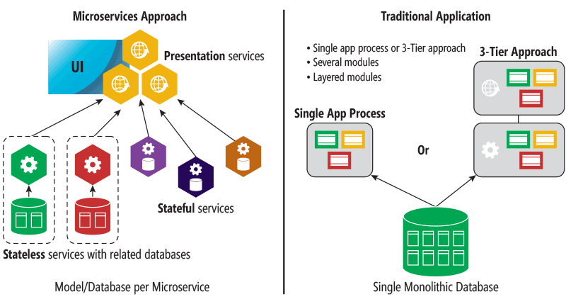

Additional information about mS, best practices are detailed in the AT&T mS Whitepaper available at the following link: [mS Whitepaper](https://tspace.web.att.com/files/app/file/2e6014b5-5c7f-4245-86e3-cdb4b13b489d).

## Scope of the Document

* Software Architecture and mS (Go)
* Business Domain Knowledge for mS Development [Go]
* mS and Bounded Context [Go]
* API One Platform & mS [Go]
* mS Naming, implementation and AJSC6 Platform [Go]
* mS Design Principles, Patterns & Anti-patterns [Go]
* Resiliency and mS Architecture[Go]
* Software Packaging, Delivery and Deployment [Go]

**Appendix**

* mS Training Detail
* mS design & development Policy
* Software Resiliency Engg. mS Strategy [[GO](https://tspace.web.att.com/communities/service/html/communityview?communityUuid=3554733d-7fab-4a9f-a990-27d1231e94e9#fullpageWidgetId=Wbb75fd38cf2f_4f0a_b6f2_a97235fedaa1&file=4e6eb9c6-b740-4374-a20b-adfe6d14c728)]
* mS Testing, Modelled & Non-modelled mS AJSC User Guide [[Go](#_Appendix-A_(AJSC_6,)]

**2 Business Domain Knowledge for mS Development**

The mS design practice must align with the following two principles:

* Principle 1: Single Capability Focused: Is the scope of the service's business or technical capability of the correct size or focus?

* Principle 2: Encapsulation: Does the service hide its implementation details? Is access to the service's persistent data private to the service?

Below diagram captures the “Single Focus” principle that is at the root of mS architecture:

The single focus principle begins with business’s *vision statement* and is broken down by sub-domain.

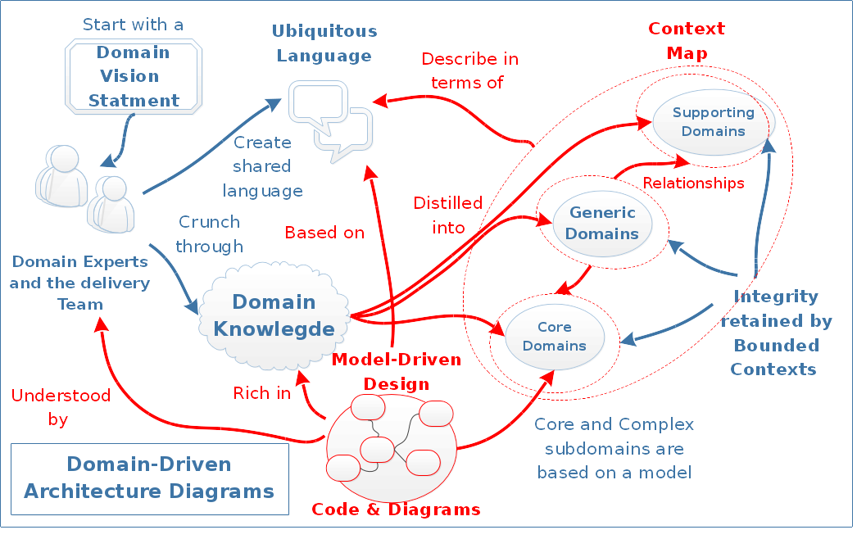

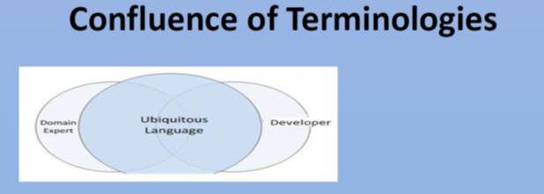

Once identified, where an existing API may support the domain, the mS may require decomposition. If the API violates single domain capability, it requires decomposition

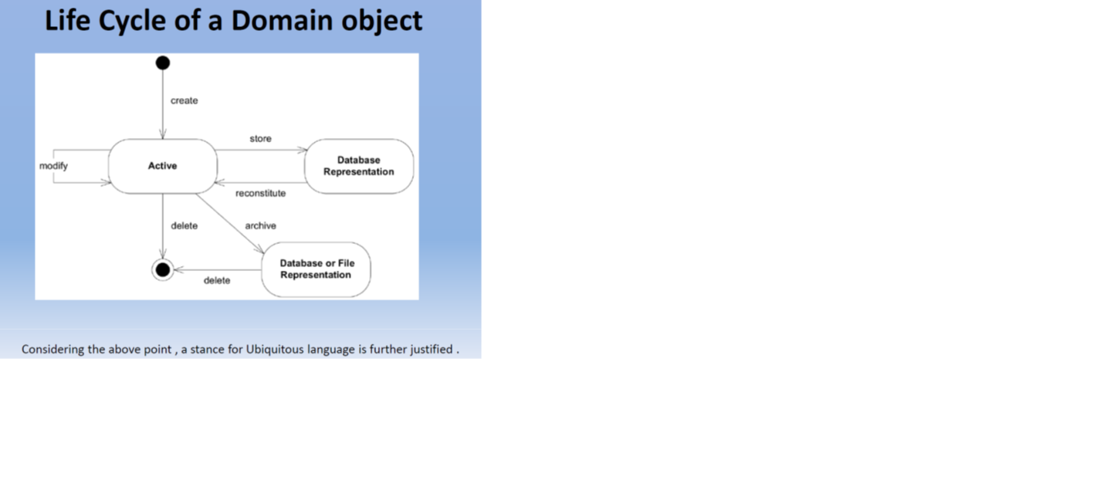

**3 Software Architecture and mS**

The [10 mS Guiding Principles](https://wiki.web.att.com/display/microservices/mS+Principles) describes the mS architecture software development practices. Below depicts the 4 characteristics aligning with the 10 principles

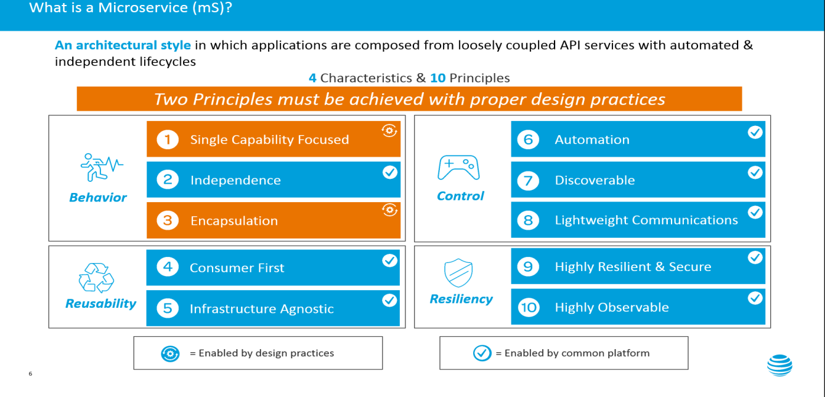

From a design perspective, mS focus on the business capabilities. Execute or perform around a domain of operations. For example, following is picture showing the interaction for Account, Merchant and Payment domain:

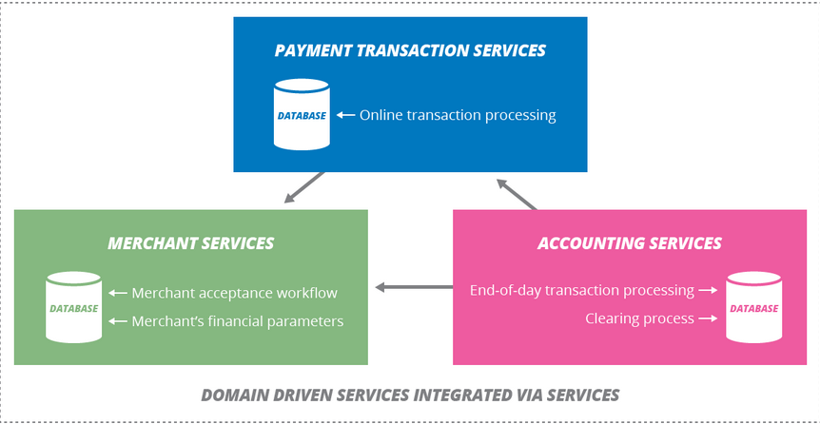

**mS architecture and taxonomy around it**

Since mS is an architectural practice, projects must use the mS framework to manage the mS development life cycle.

Janakiram defines mSs as “fine-grained units of execution.” He continues:

“They are designed to do one thing very well. Each mS has exactly one well-known entry point. While this may sound like an attribute of a component, the difference is in the way they are packaged. mSs are not just code modules or libraries – they contain everything from the operating system, platform, framework, runtime and dependencies, packaged as one unit of execution.

Each mS is an independent, autonomous process with no dependency on other mSs. It doesn’t even know or acknowledge the existence of other mSs. mSs communicate with each other through language and platform-agnostic application programming interfaces (APIs). These APIs are typically exposed as Rest endpoints or can be invoked via lightweight messaging protocols such as RabbitMQ. They are loosely coupled with each other avoiding synchronous and blocking-calls whenever possible.”

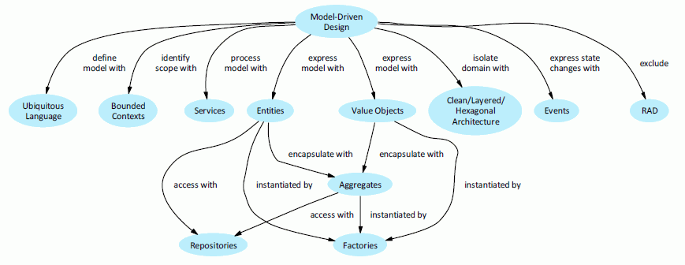

Below are terms that will be used in this document:

* **Entity** – Unique identifier associated with an entity. E.g., Each record in a table with primary key. Primary Key will be the unique identifier to differentiate between records.
* **Value Object** –Value Object represented by its data. It does not have a unique id, e.g., Address. However, based upon context, a designer must decide if an Object should be used as Value Object or an Entity.
* **Aggregate** – Aggregate is a cluster of coherent objects with complex associations. Aggregate is used to ensure invariants and guarantee the consistency of the relationship between these objects. Aggregate is used to control locking and guarantee transactional consistency in the context of distributed systems.
  + An Aggregate chooses an Entity to be the root and control access to objects within Aggregate through this root. The root is called the **Aggregate Root**.
  + An Aggregate is a unique identifiable by its **ID** (usually a UUID/GUID).
  + Aggregates refer to each other by their ID – they NEVER use memory pointers or Join tables

As an implementation practice, entire aggregated should be used to avoid latency. If the entire aggregate is not used, it was probably not an aggregate and performance can be improved with asynchronous updates. Transaction should be formed around business units of consistency rather than technical requests to avoid data corruption and simplify processing. The entire aggregate should be processed synchronously within a transaction.

Major architectural component for the mS architecture:

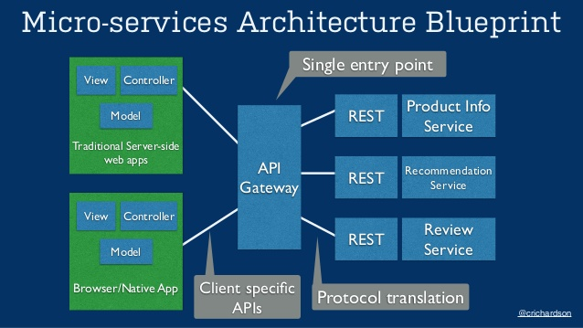

This diagram depicts the mS, communication which will create a business process.

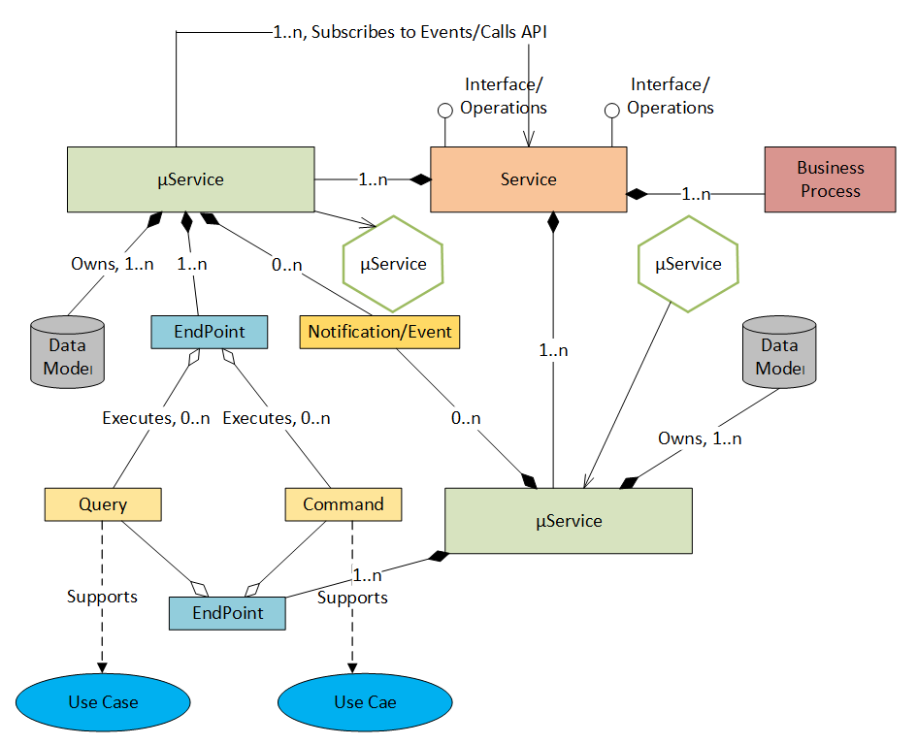

Developing a new or migrating from mS bundle requires the following:

* Granular capability driven design
* Lightweight Communication (RESTFul/JSON) [NOTE: SOAP can be used by it is not light]
* Standard portable container (Docker) after package
* Runtime automation including scaling, configuration and upgrade(K8).
* One-click deployment (including configuration and properties)
* Automatic jUnit testing and SonarQube scan

## 3.1 SoR and Business Domain Capability

A micro service design intends to capture a focused operation. A service design is developed around a business domain or sub-domain operations and follows domain driven design.

For ‘single capability’, the operations are delivered using Domain Driven Design principles. Service's capability should not be larger than a bounded context and not smaller than an aggregate root. Following depicts the necessary mS that supports a business e.g.

SoR mS reads and writes the data directly from a database. This encapsulates the data domain operation for a logical entity that is reflected in physical database design. A fundamental principle of a micro service keep the data private to that service; not shared with other service.

The below picture captures all SoR services:

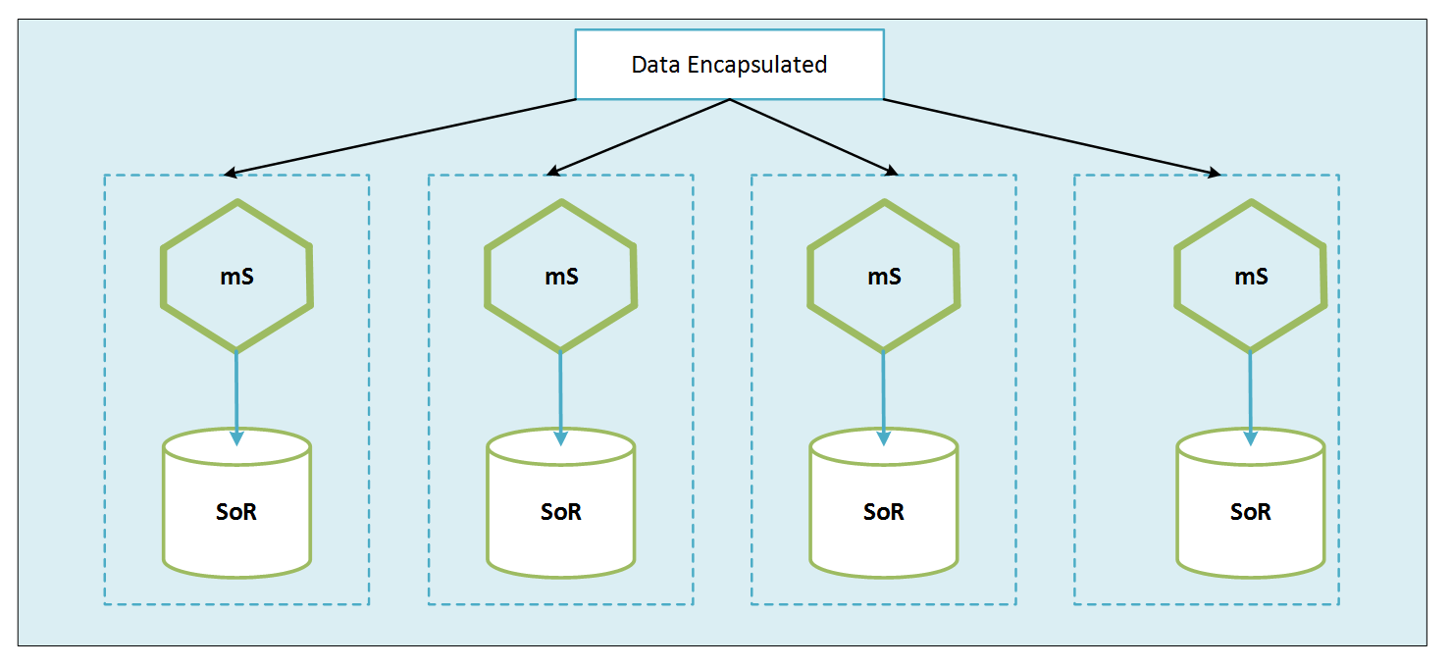

However, an enterprise software solution has multiple tiers or layers in it. Following is a description of the different categories of micro service to be scored.

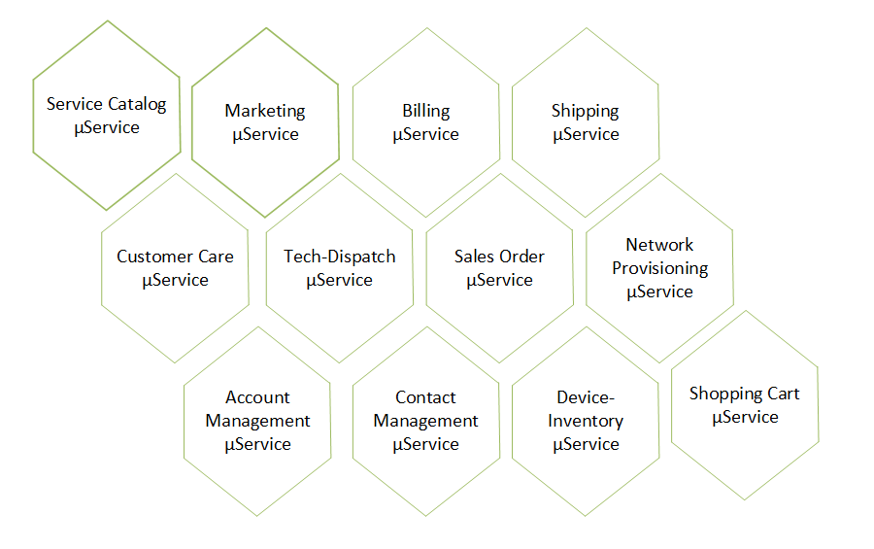

Domain Driven Design starts with Business Domain Analysis; relevant business concepts and processes. Modelling domain is not the same as modelling persistence. It is a mindset. The application ***D***esign is ***D***riven by the business

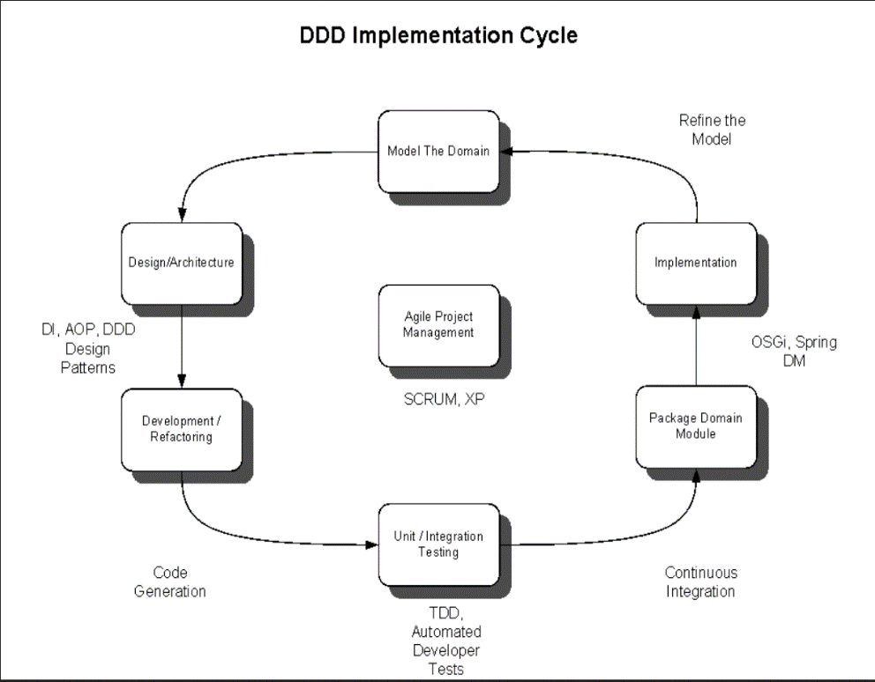

### 3.1.1 Decomposition of a Domain

The following practices should be used when creating the domain model:

* Do the linguistic analysis and avoid ambiguity and synonymy
* Identify the noun phrases from the discussion above for figuring out the concepts/conceptual classes
* Pay attention when noun phrase may represent attributes---when the concept represent just a number or a string.
* Pay attention when noun phrase may represent conceptual classes---when the concept may represent multiple behavior or stores state information.
* Verbs can also be class when it stores state.

The model domain drawing and bounded context adjustment takes place once the concepts and purpose is determined. Once the Aggregate Root is known, the communication starts between the Aggregate and Entity value object

Below two diagram depicts objects interaction in the software context to support the business operation.

. 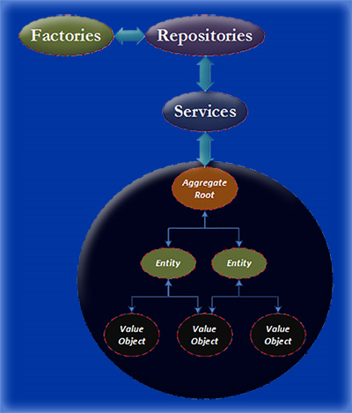

Sequence Diagram:

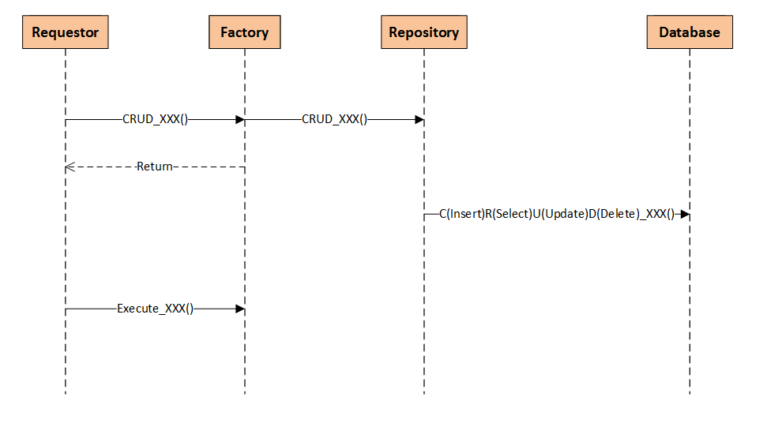

The Bounded Context capability mS discussion below.

#### 3.1.1.1 “ Catalog (Service/Product) Management” Business Capability & SoR implementation

**Function:**

Developer: What is a Service or Product?

Domain Expert**: Service or Product** is offering by the company, e.g., high speed internet connectivity, pre/post-paid mobility services etc.

Developer: Are there different levels in a service?

Domain Expert: Yes, there could be different levels of **features** in a **service**, e.g., call forwarding is a **feature** for a mobility service.

Developer: How is a service packaged?

Domain Expert: A complete service may include, for example unlimited SMS and unlimited talk time. This will constitute an **Offer**

Developer: Do you sell **hardware**/**Product** that executes a service?

Domain Expert: Yes, such as a cell phone

Developer: Do the service provisioning require network **equipment/device**?

Domain Expert: yes, **devices** are providedto our **customer** for some service. E.g., for wireless home phone, a base station is provided to connect to power at home. Home phone service is supported through that device.

Developer: Are **bundled** services offered, e.g., mobility service with home internet?

Domain Expert: Yes **bundled** services are offered

|  |  |
| --- | --- |
| Concept | Purpose |
| Service | Category of Services offered as Telco, Mobility or Entertainment Product, Prepaid & Postpaid |
| Device | Providing Service may require device/hardware shipment |
| Features | Features are parts/components/properties of the service |
| Bundle | Multiple Services that is offered as a Bundle |
| Offers | Offers associated with service |

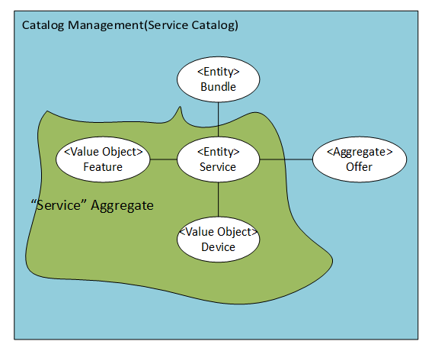

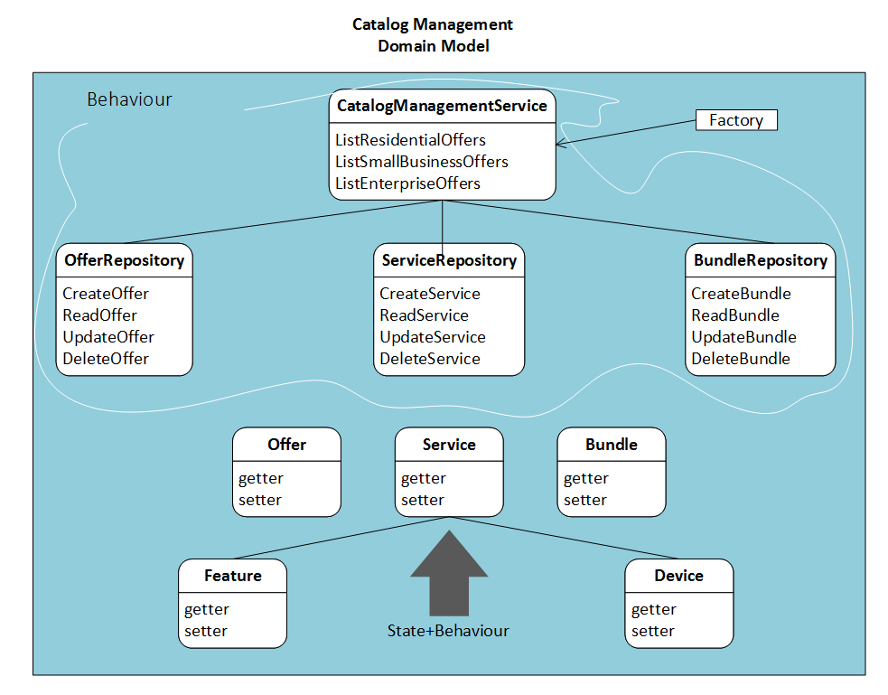

**CRUD Operations involving this domain:**

* CRUD Bundle
* CRUD Service
* CRUD Offer (Telco, Mobility, Entertainment)

Other Possible Operations:

* View Residential/Small Business/Enterprise Offers
* RetrieveServicesByOfferId
* RetrieveBundlesByOfferId

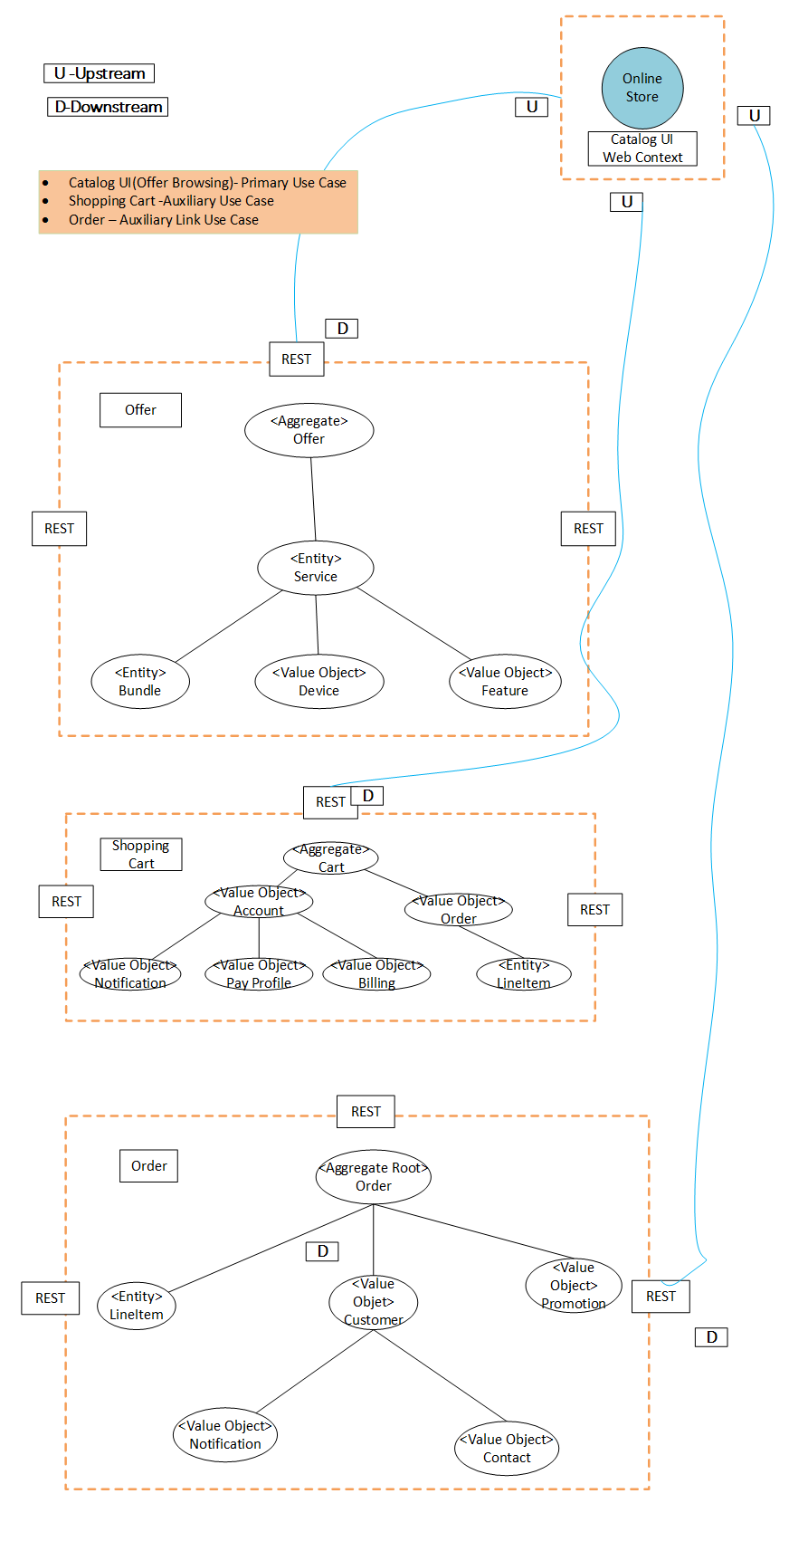

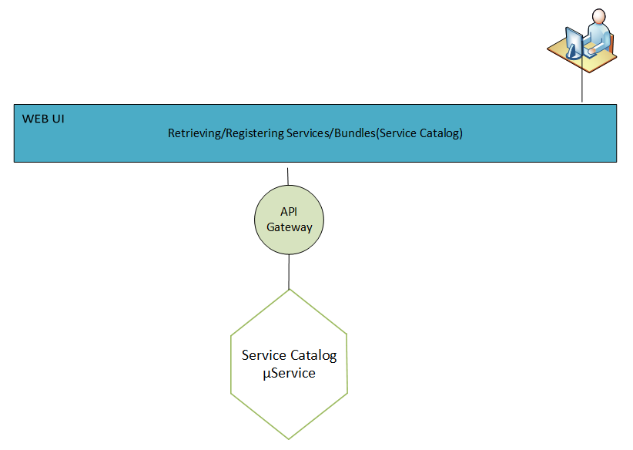

#### 3.1.1.2 “Payment” Business Capability & SoR implementation

**Function:**

Payment Management Context: Telecom **Order is** paid by a **Card or Bank Account**. Customer can also set up ‘**AutoPay’** for Post-Paid **Bill**. Customer may also pay the bill directly to an **agent**.

|  |  |
| --- | --- |
| **Concept** | **Purpose** |
| Person | Card/Account Holder who is paying for the order |
| Card, A/R | Card, A/R Account details used to pay the Bill |
| Bill | Invoice amount |
| Autopay | Monthly deduction of the bill from Pay Source |
| Agent | Payment Agent who takes the bill. |

##### a) Payment Agent & SoR implementation

**Function:**

**Payment Agent** receives payment for Service on the merchant’s behalf. Since there many bill payments option, a Payment agent may not support all options.

A customer is able to pay a bill using cash or online payment (Bank or credit card). **Payment Agent,** using a store front accepts payments. Below are few common way to pay bill:

* + credit_card
  + paypal
  + wire_transfer
  + check
  + cash

|  |  |
| --- | --- |
| Concept | Purpose |
| PaymentAgent | Agent with business ID who takes the bill |
| Transaction | Record of bill pay |
| Contact | Contact details of the Agent |
| Location | Location details |
| Hour Open | Operation Hour of the store |

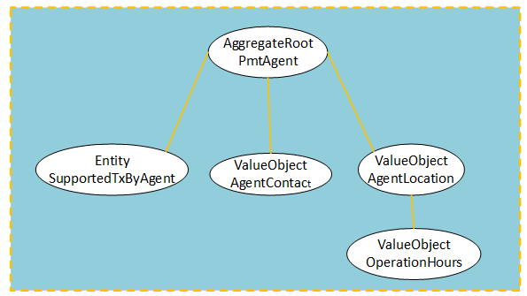

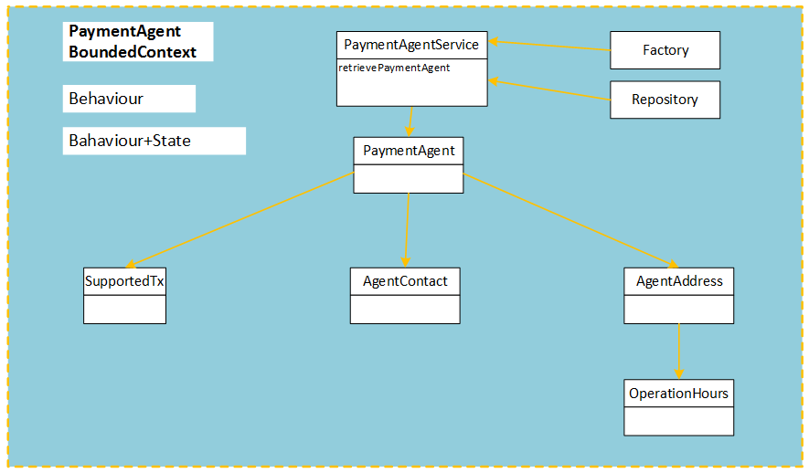

**CRUD Operations involving this domain:**

* CRUD Payment

##### b) Payment Profile & SoR implementation

**Function:**

**Payment Profile** Context supports the recording of preferred payment method and details about account information.

A consumer creates a profile with their service provider used to pay bills. Validation is performed by the provider to ensure consumer’s information is accurate.

A Consumer establishes:

* Bank Profile
* Multiple Credit Card Profile
* PayPal

|  |  |
| --- | --- |
| **Concept** | **Purpose** |
| PayingAccount | Account used to pay bill |
| CardInfo | Credit Card information details |
| BankAccount | Bank Account Information Details |
| CardCodeRange | Reference data to identify Card |
| BankRouting | Reference Data to identify Bank |
| BlockedAccount | Account that has been blocked |
| BlockedCard | Flagged Card |

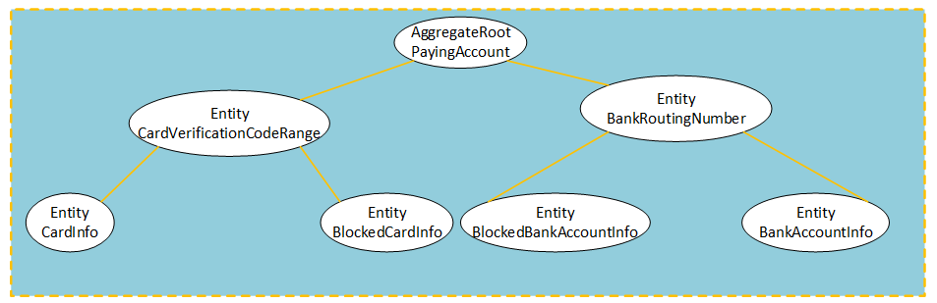

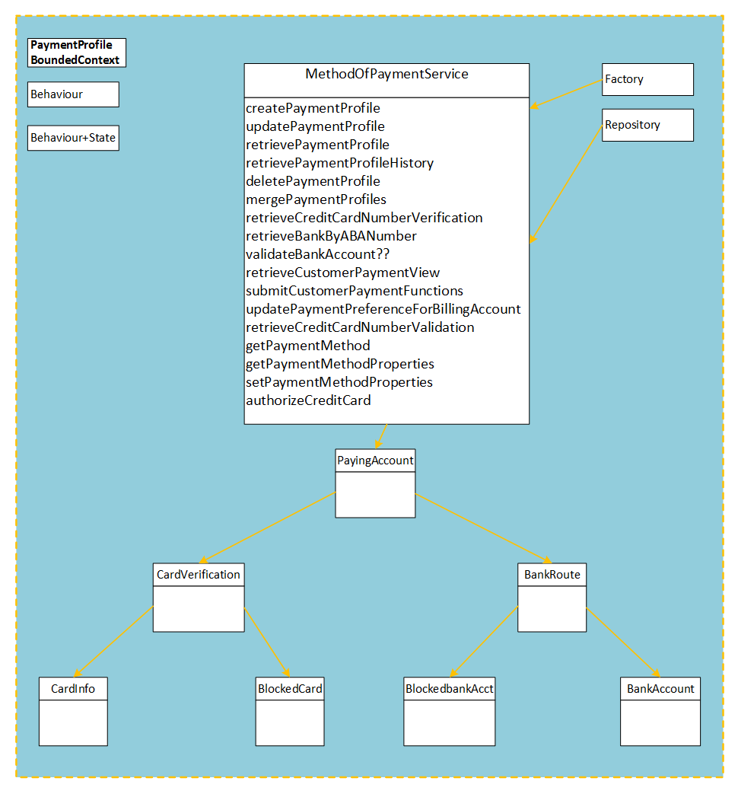

**CRUD Operations involving this domain:**

* CRUD Client Payment profile

##### c) Managing Payment & SoR implementation

**Function:**

**Payment Management** includes paying the bill, make commitment to pay the bill, or establishing a **recurring** bill pay process.

Based upon the Payment Profile selection, a **payment** can be made same day or at a future date using the profile data

A **payment gateway** can interface with a RTP(Real time Payment) platform for all the electronic bill pay transactions.

Along with the bill pay**, payment management** also includes cancelling a payment, refunding or reversing a payment.

|  |  |
| --- | --- |
| Concept | Purpose |
| Payment Management | Payment Account of the Customer purchasing service |
| Recurring | Recursive pay, auto paying the bill |
| Payment Gateway | An entity that has interface with Real time payment platform |
| Future | Paying bill in the future, PromisePay |
| Payment | Transaction Recorded when bill paid |
| PaymentPlan | Setting up a mechanism for bill pay |

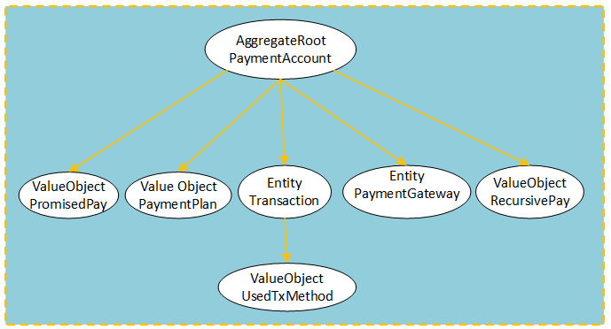

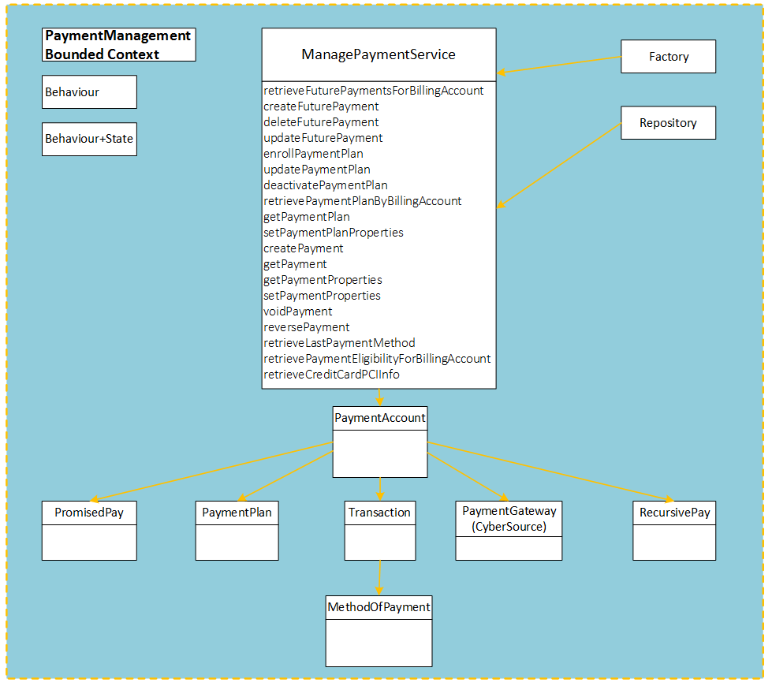

**CRUD Operations involving this domain:**

* + CRUD Payment

Implementation of a payment management context requires information from payment profile sub domain. An alternative design shown below but has high Cache data storage cost and implementation of event listener processing.

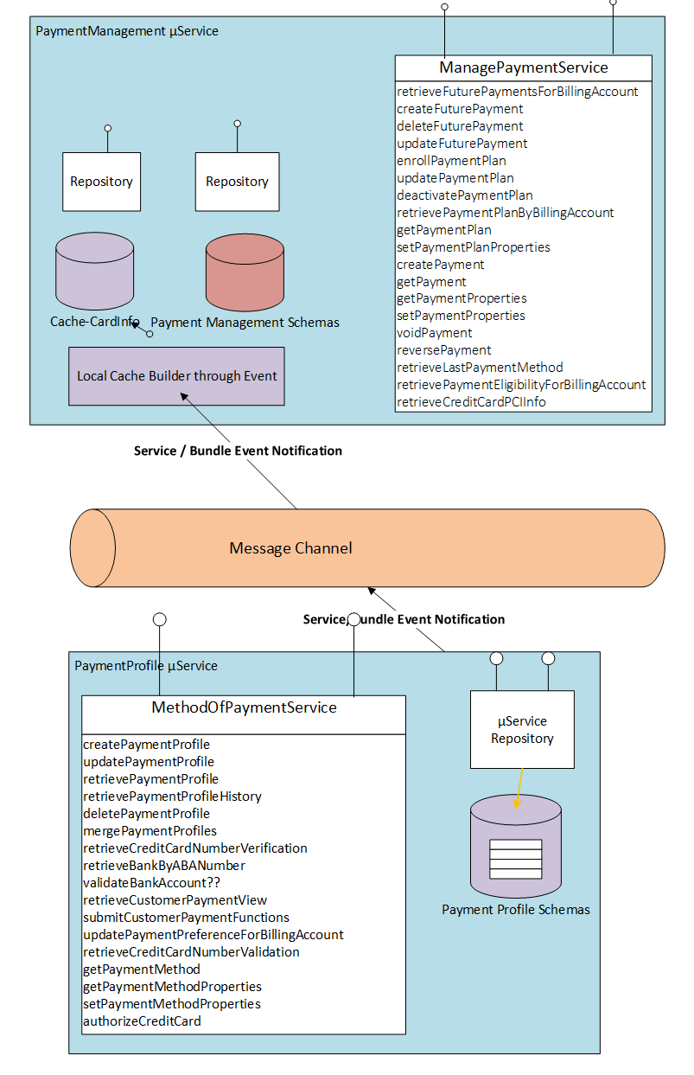

##### d) Credit Policy & SoR implementation

**Function:**

**Credit Policy** is necessary for business growth but has risk and cost when the Client defaults. When customer purchase a product or service, a **Credit Decision** is made about the customer ability of pay. There is ‘**qualification criteria’** for a Credit Decision.

Credit purchases requires a business to imposes **Terms and Condition** for the sale

|  |  |
| --- | --- |
| Concept | Purpose |
| Credit Decision | A decision made for a prospective Client about credit |
| Qualification Criteria | The driving rules for the prospective customer for the credit decision made |
| Terms & Conditions | Business imposed Terms and Conditions for the client when buying service/goods |

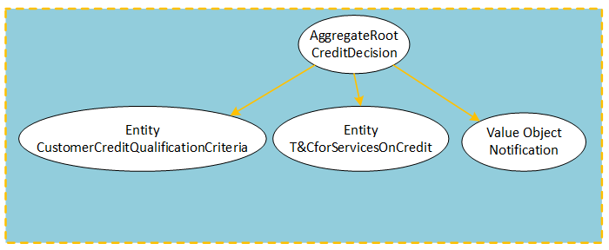

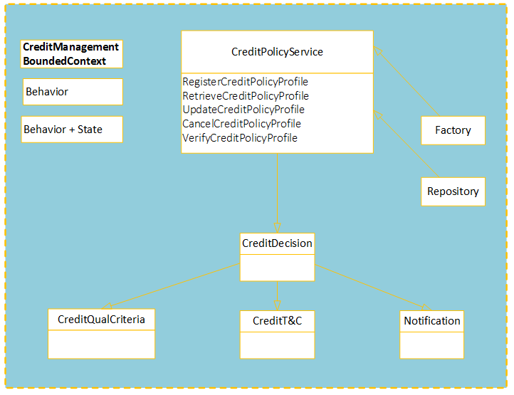

**CRUD Operations involving this domain:**

* CRUD CreditPolicy

**Other Possible Operations:**

* VerifyCreditPolicyProfile

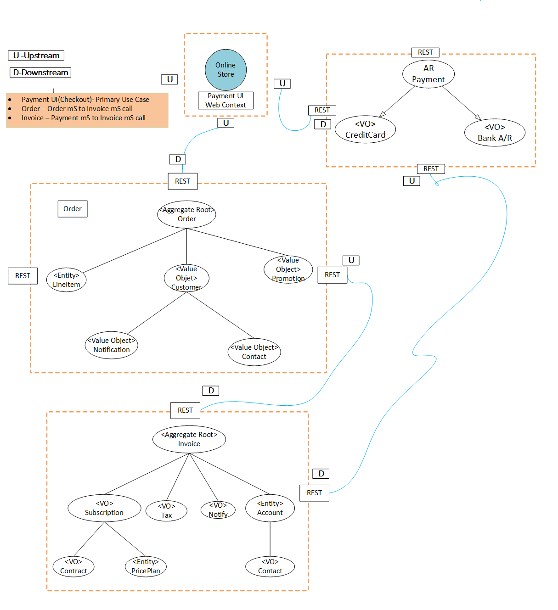

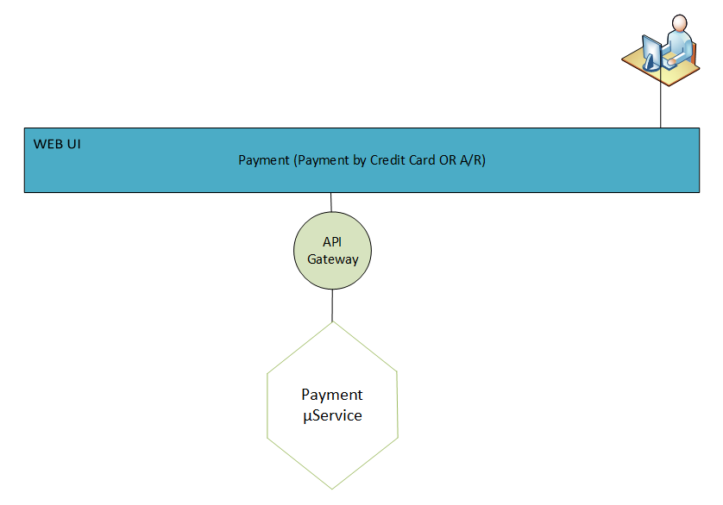

#### 3.1.1.2 “Sales/Order” Business Capability & SoR implementation

**Function:**

**Order Management Context:** Online e-Store or **sales person** assists **Purchaser** choosing telecom products. **Service** requirements are explained to the customer. e.g., qualifying devices, **credit** requirements or **contract** stipulations.

|  |  |
| --- | --- |
| **Concept** | **Purpose** |
| Purchaser | Manage Customer Information who ordered the Service |
| Service | Manage Ordered Service Information |
| Price Plan | Pricing information of the service selected with the features |
| Line Item | Manage Update Order State |
| Eligibility | Porting /Offer/Promotion eligibility |
| Credit Worthiness | Credit History check for prospective sell |
| Device | Manage Device Shipment (Shown or Hidden to the Purchaser) |
| Circuit/telephone number | Activity needed at the network level for the service |
| Contract | Client agrees to maintain the service for duration of time, early termination fee will be applied is contract broken |
| Sales Person | Representative help client completing the order |
| Notification | Notification sent about order status |

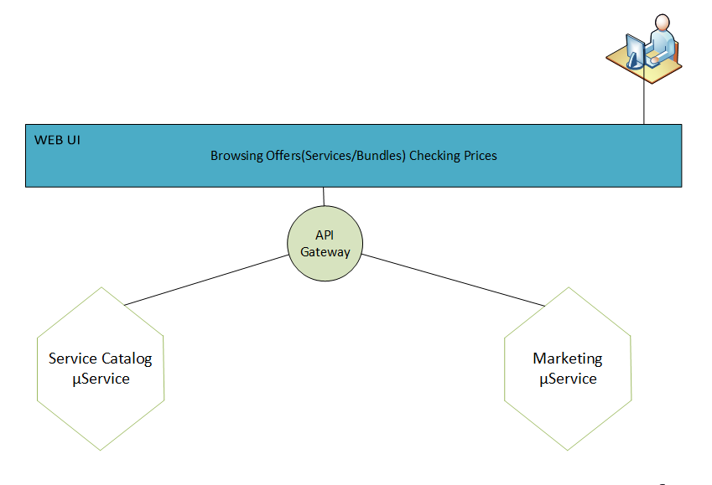

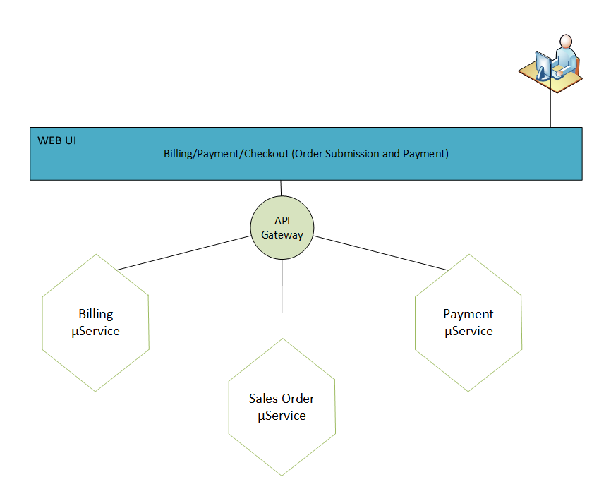

**CRUD Operations involving this domain:**

* CRUD Order
* CRUD Line Item

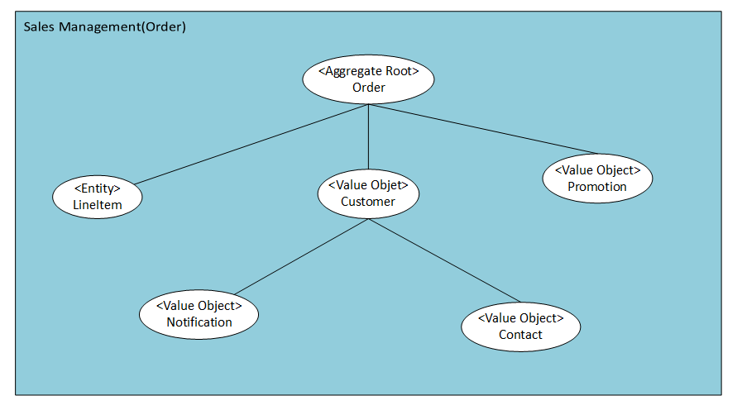

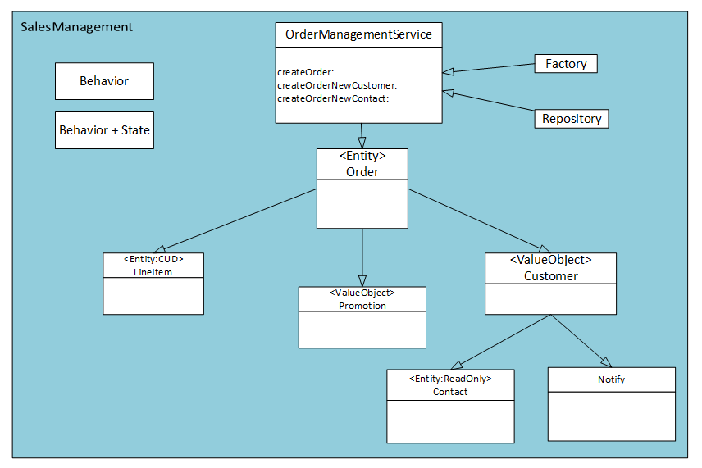

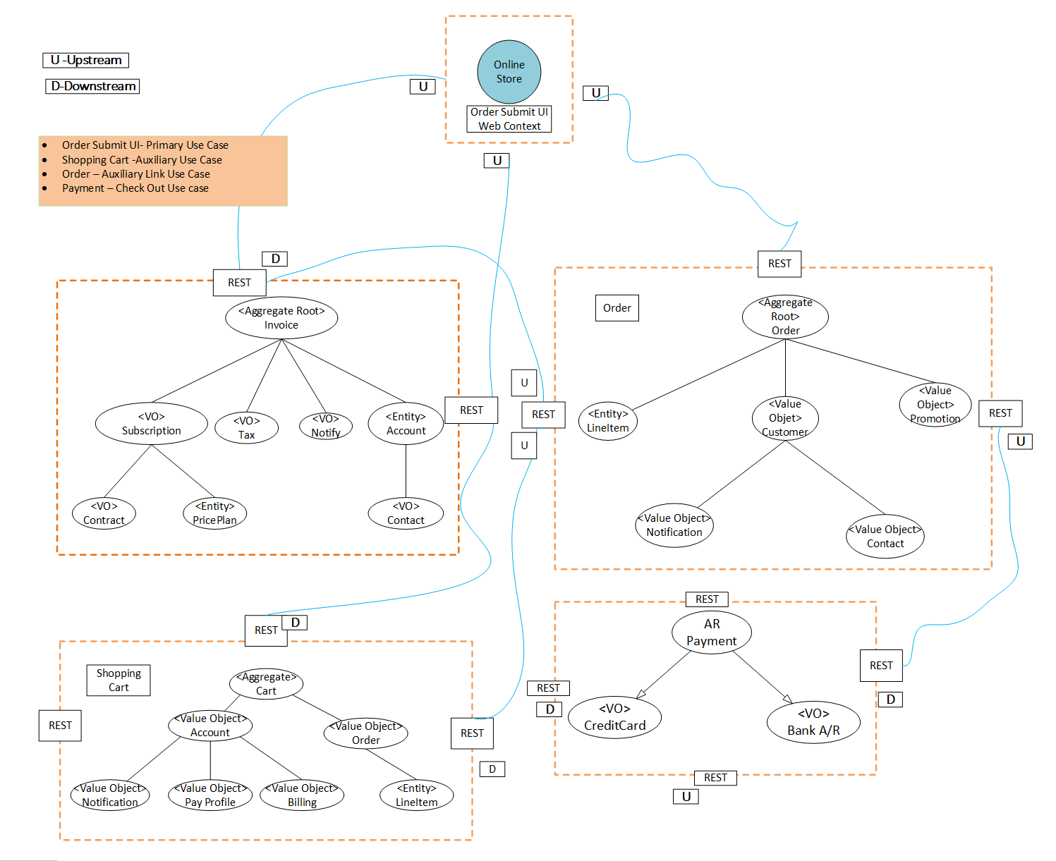

#### 3.2.4 “Marketing” Business Capabilities & SoR implementation

**Function:**

**Product Marketing Context**: Marketing develop plans to sell their **services**. They may offer **promotions** for a particular **region** and to target group of **people**.

|  |  |
| --- | --- |
| **Concept** | **Purpose** |
| Prospect Client | Client assumed to be becoming AT&T Customer |
| Service | Service promoted for sell |
| Promotion | Explains promotions that may be advertised |
| Service Availability | Determines which area/zip code this service will be available |
| Offers |  |
| Notification | Notification sent about Promotion, New service |

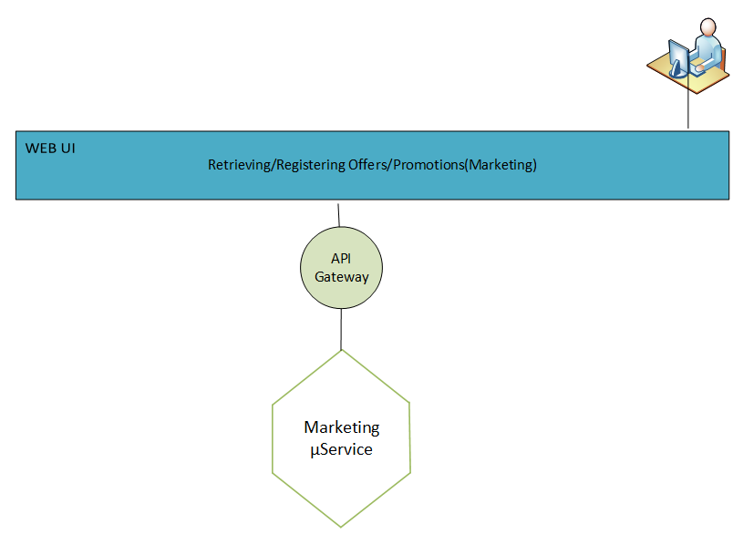

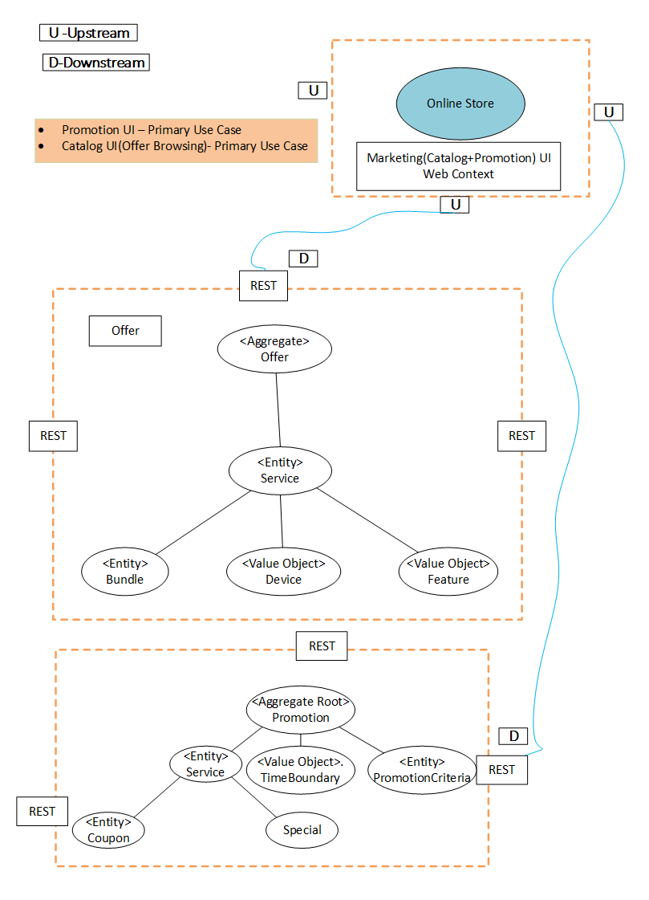

**CRUD Operations involving this domain:**

* CRUD Offer
* CRUD Promotion
* CRUD Prospective Client

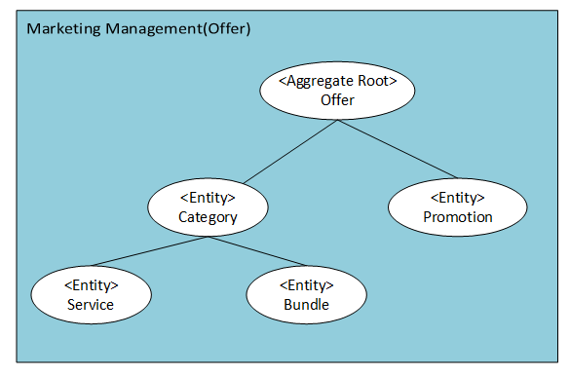

* 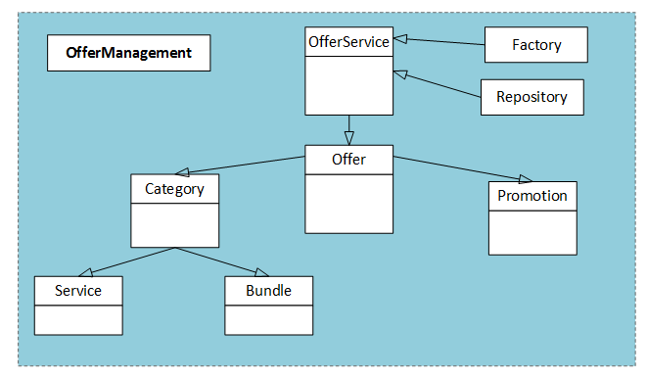

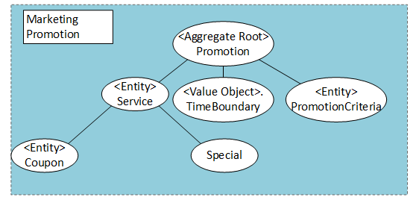

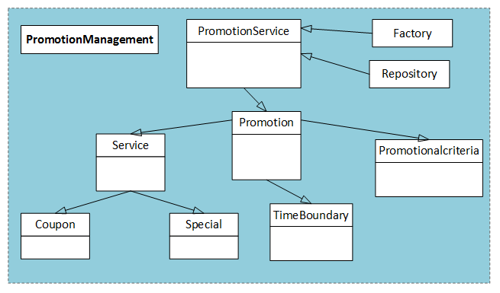

#### 3.2.5 “Billing/Accounting” Business Capability & SoR implementation

**Function:**

Billing Management Context: **Customer Account** for the subscribed services will receive **invoice** at billing **address** or **email** and pay the bill using **Credit card** (debit/credit).

|  |  |
| --- | --- |
| **Concept** | **Purpose** |
| Customer Account | Person to be billed |
| Invoice | Bill prepared for the Client and send |
| Mail | Mail or email the invoice |
| Address | Invoice to be send to Contact address |
| Credit Card , A/R | Bill pay either by Credit card or from Bank Account |
| Notification | Notification sent about Billing |

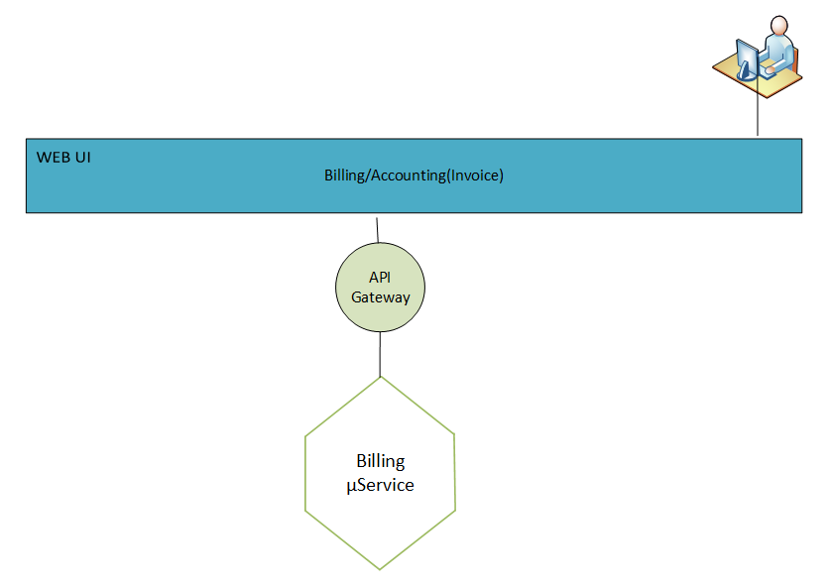

**CRUD Operations involving this domain:**

* CRUD Invoice
* CRUD Billing

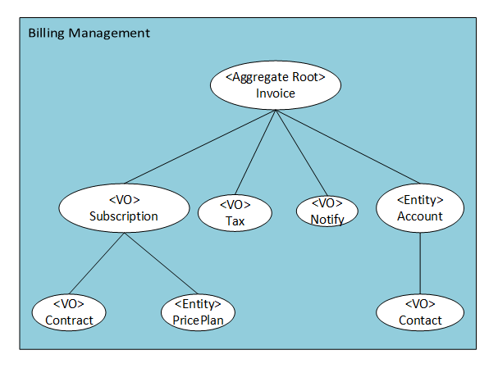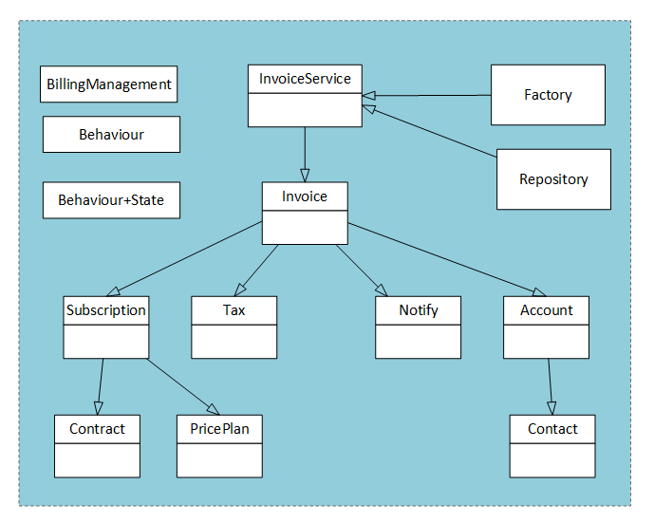

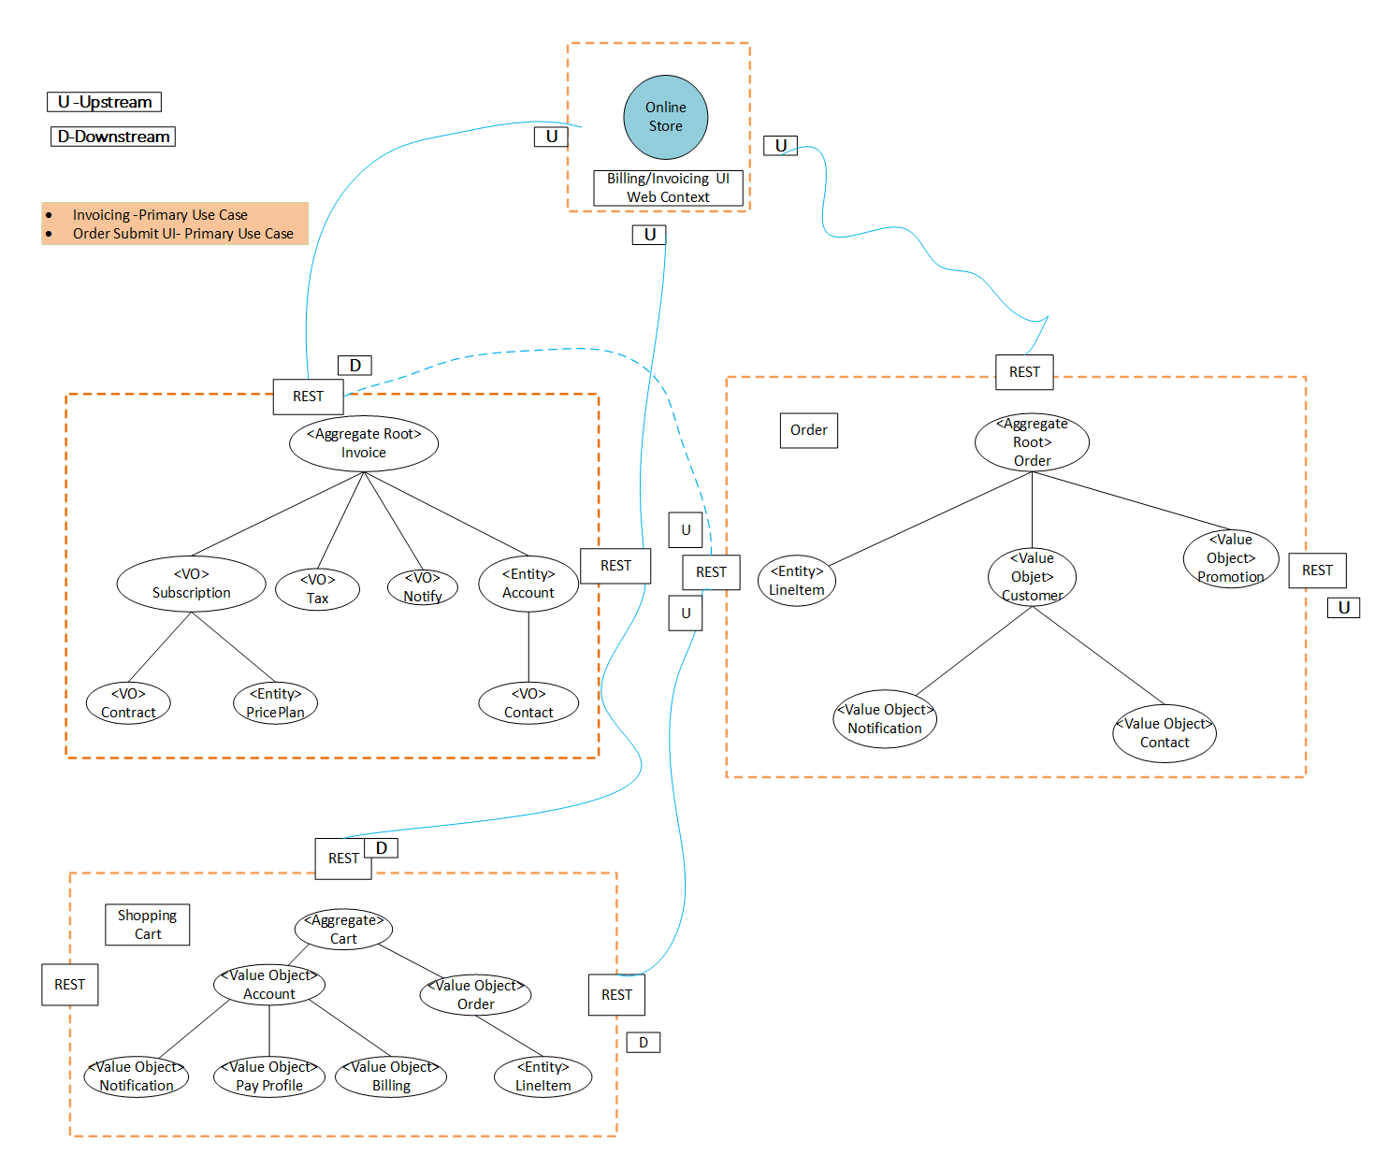

#### 3.2.6 “Shipping/Fulfillment” Business Capability & SoR implementation

**Function:**

**Shipping Context**: A device is shipped to the **Recipient’s Address** service.

|  |  |
| --- | --- |
| **Concept** | **Purpose** |
| Recipient | Person receiving the shipment |
| Address | Address where device will be shipped |
| Address Gateway | Validation of Shipping address |
| Notification | Notification sent about Shipping status |

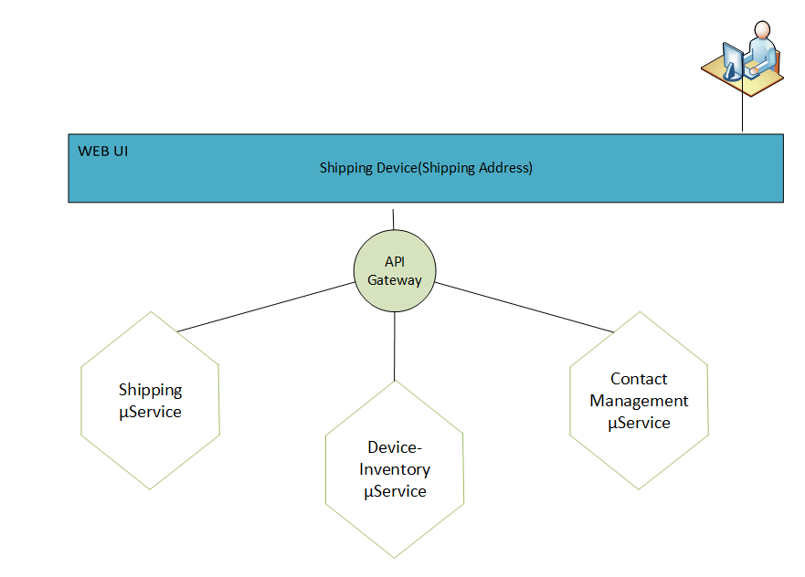

**CRUD Operations involving this domain:**

* CRUD Shipment
* CRUD Shipping Address

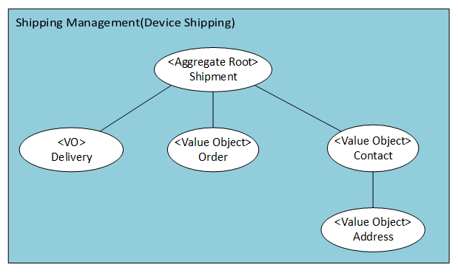

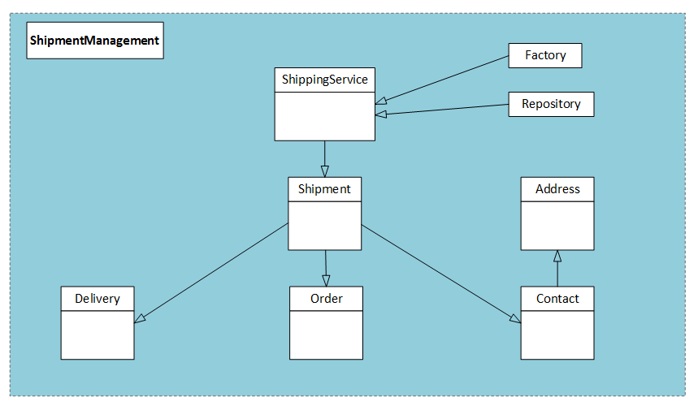

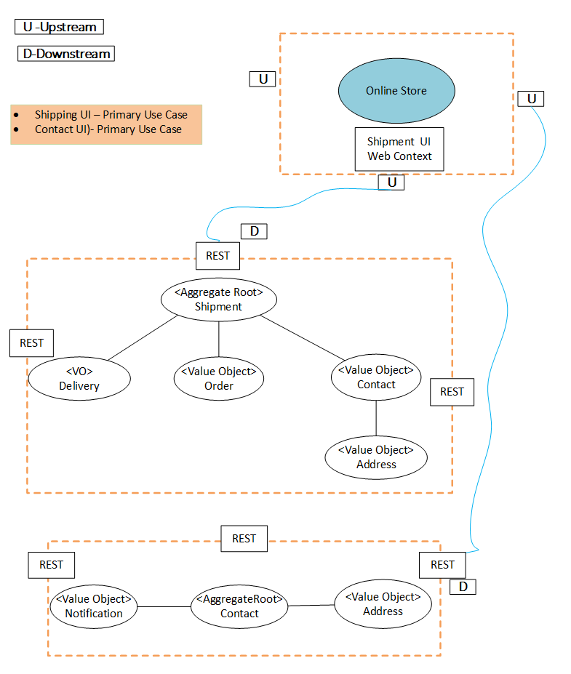

#### 3.2.7 “Device Inventory” Business Capability & SoR implementation

**Function:**

**Device Inventory Context**: C**ategory** needed by business unit to supports AT&T services.

|  |  |
| --- | --- |
| **Concept** | **Purpose** |
| Category | Device that supports the business type |
| Device | Device detail information |
| Device Spec | Attributes associated with the device |
| Service | Services support by the device. |

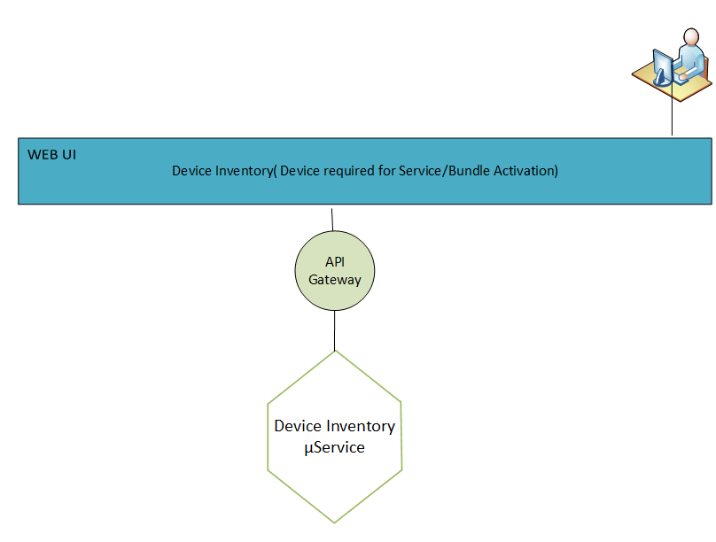

**CRUD Operations involving this domain:**

* CRUD Category
* CRUD Device
* CRUD Device Spec

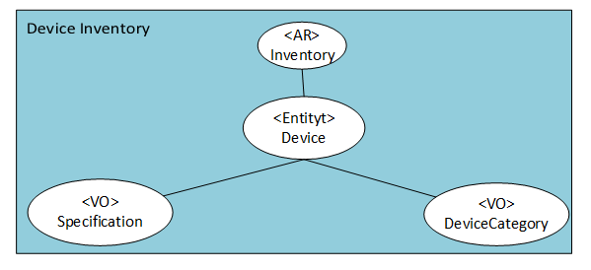

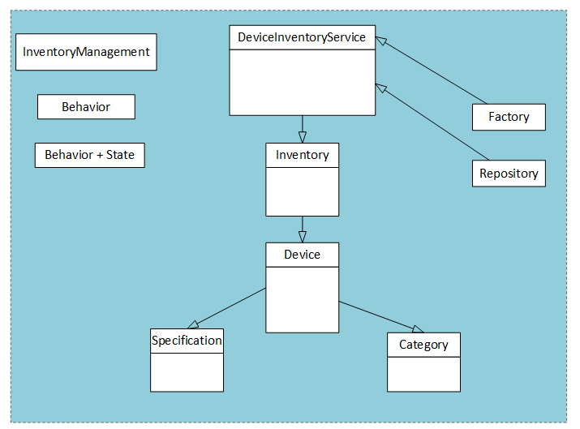

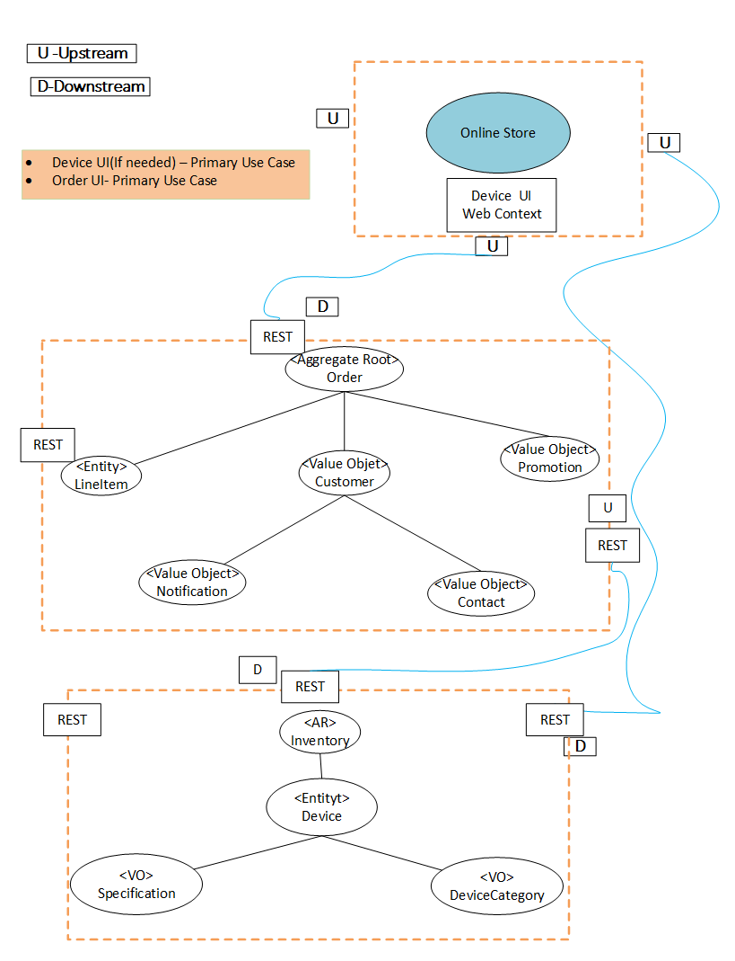

#### 3.2.8 “Network Provisioning” Business Capability & SoR implementation

**Function:**

Network Provisioning Context: Service must be provisioned on the AT&T network and **devices** to **activate/deactivate** device settings for the associated **Account.**

|  |  |
| --- | --- |
| **Concept** | **Purpose** |
| Device | Device Information that is in use for providing service |
| Activation/Deactivation | Turning on/off , setting parameters for the features subscribed by client |
| Port Number(Circuit) | Porting Eligibility of the line |
| Account | Service provisioned for the account |
| Notification | Notification sent about provisioning status |

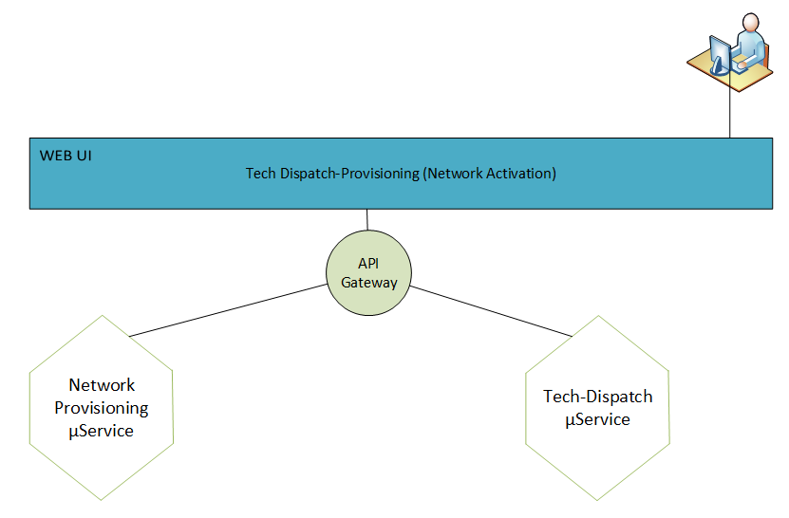

**CRUD Operations involving this domain:**

* CRUD Provision
* CRUD Circuit

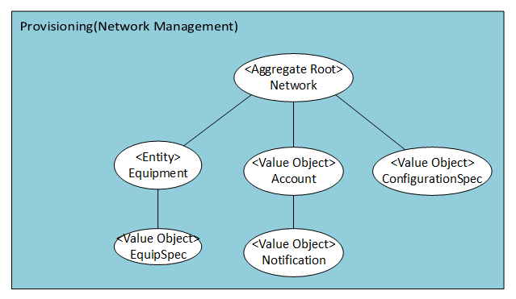

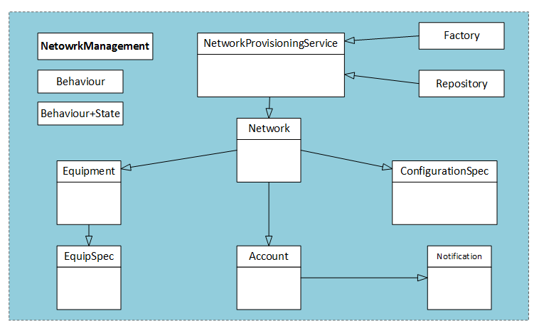

#### 3.2.9 “Customer Service” Business Capabilities & SoR implementation

**Function:**

Customer Service Context: **Customer** calling Customer care for **service or collection** issues to understand the resolution.

|  |  |
| --- | --- |
| **Concept** | **Purpose** |
| Customer | Calling for Help |
| Service | Service issue |
| Group Access | Subscriber that has access to the Service |
| White List | Subscriber access to the device functionality |
| Black List | Subscriber do not have access to the device functionality |
| Ticket | Tracking information for the issue |
| Trouble History | Records of past issues and resolution |
| Account History | Past records for services/payments/customers |
| Collection | Overdue payment forwarded to Collection system |
| Notification | Notification sent to ticket update |

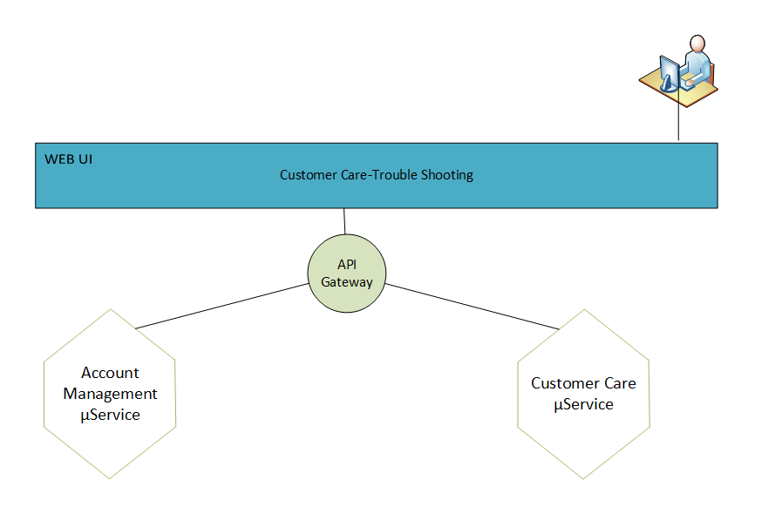

**CRUD Operations involving this domain:**

* CRUD Customer
* CRUD Account
* CRUD Billing/Shipping/Contact Address
* CRUD AccountUser

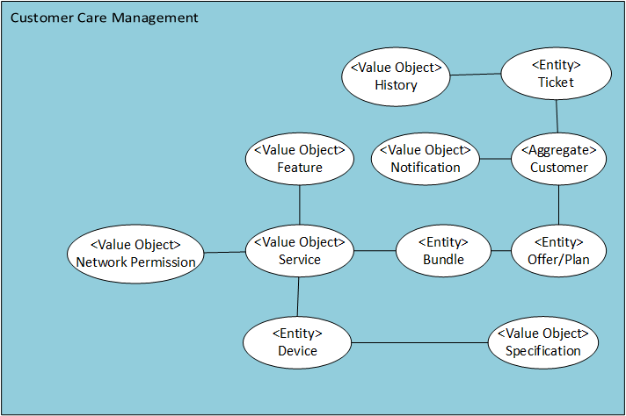

#### 3.2.10 “Account Management” Business Capabilities & SoR implementation

**Function:**

Account is the central entity in the Account Domain.

The Account domain performs the following functions:

* Provides an account-centric view of master data.
* Supports business applications with consolidated view of multiple accounts.
* Can link to party and product domains.
* Has ability to introduce new products and services by managing relationships across accounts.
* Can manages different types of agreements, such as account agreements and purchase (or vendor) agreements.

Account Management Context: **Account** is created when customer buys AT&T **B2B and B2C** services. Customers are identified by account and subscribed services

|  |  |
| --- | --- |
| **Concept** | **Purpose** |
| Account Category | B2B, B2C Account Category with business/service types |
| Account | B2B, B2C Account details with types |
| Org/Customer | Org/Customer the account belongs to |
| Subscriber | Subscribers associated with the account consume services |
| Service | Service associated with the account |

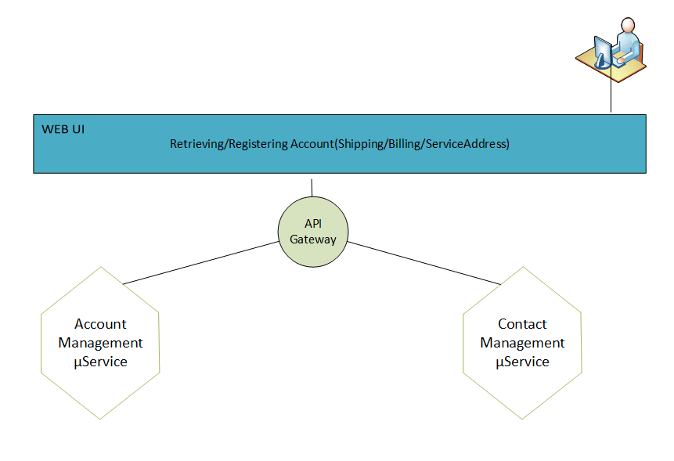

**CRUD Operations involving this domain:**

* CRUD Account Category
* CRUD Account

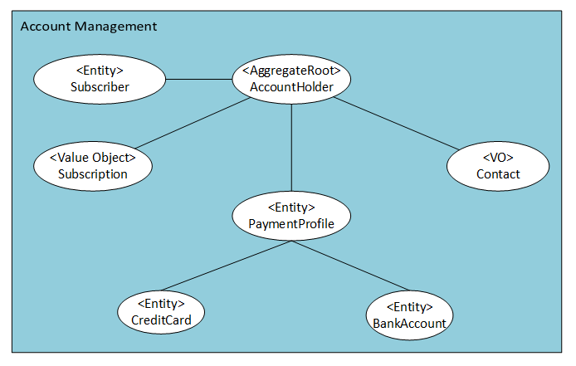

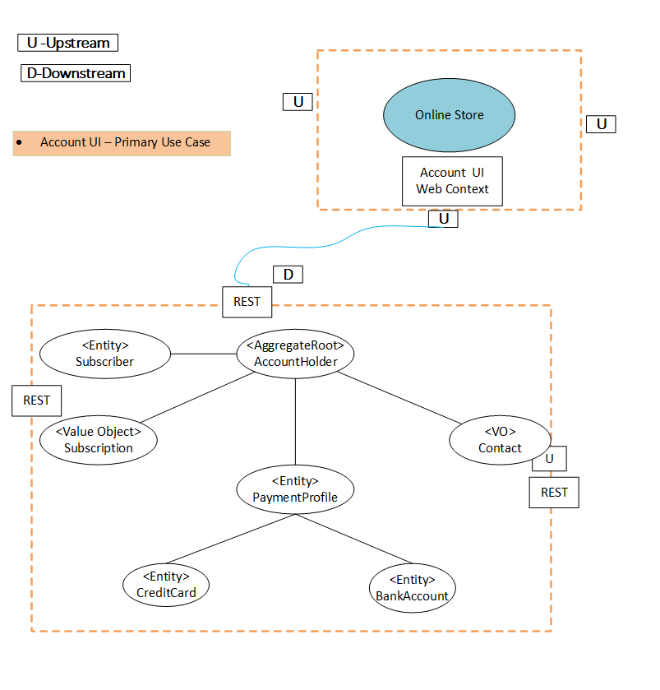

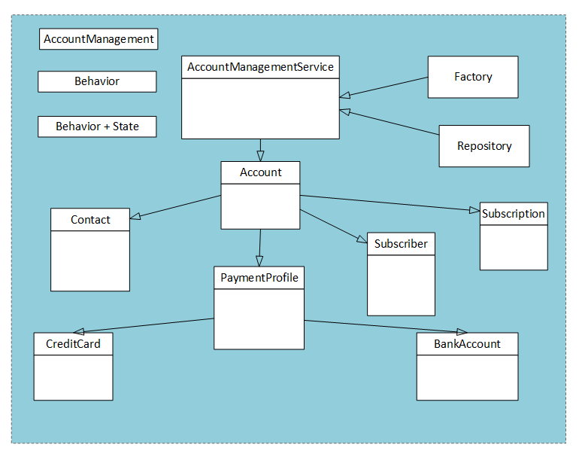

#### 3.2.11 “Tech Dispatch” Business Capabilities & SoR implementation

**Function:**

**Tech Dispatch Context**: Services that requires a **technician** to install is dispatched to the service **address** at a specified date and time.

|  |  |
| --- | --- |
| **Concept** | **Purpose** |
| Technician | The person needs to be onsite for provisioning |
| Calendar | Date Time tech will show up |
| Address | Address where tech needs to go |
| Notification | Notification set to confirm scheduling |

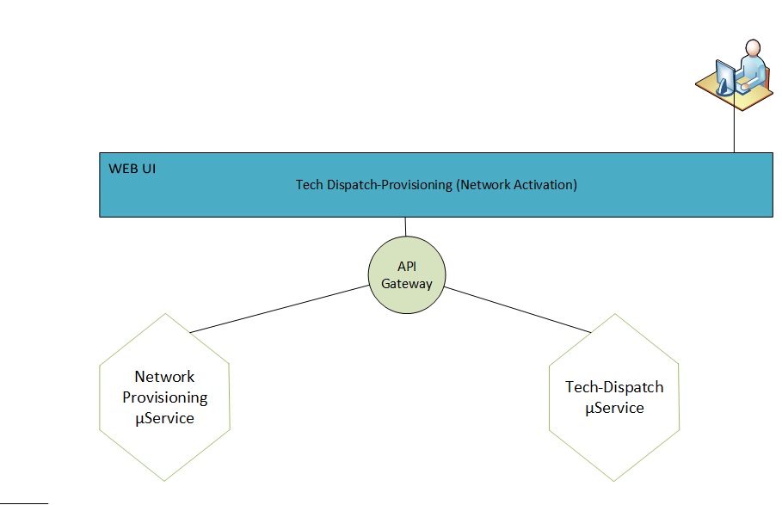

**CRUD Operations involving this domain:**

* CRUD Calendar
* CRUD TechnicianCRUD Schedule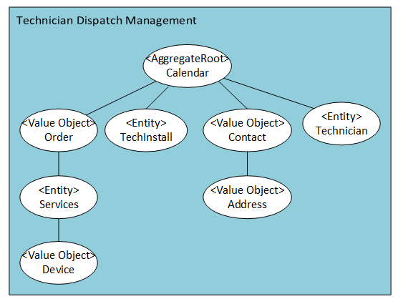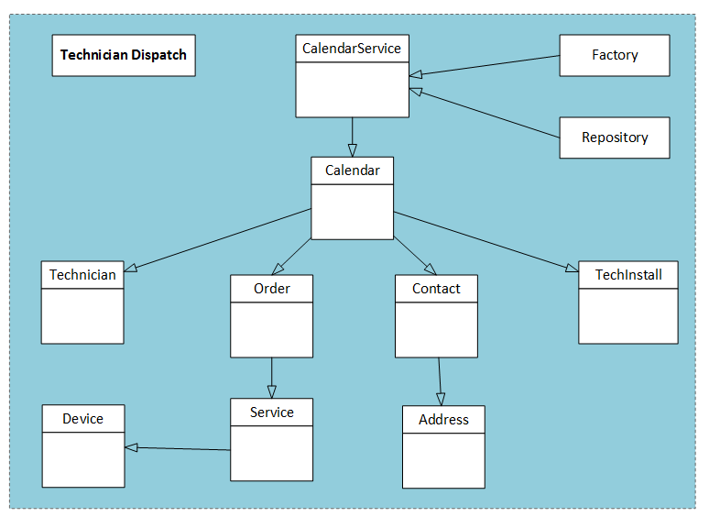

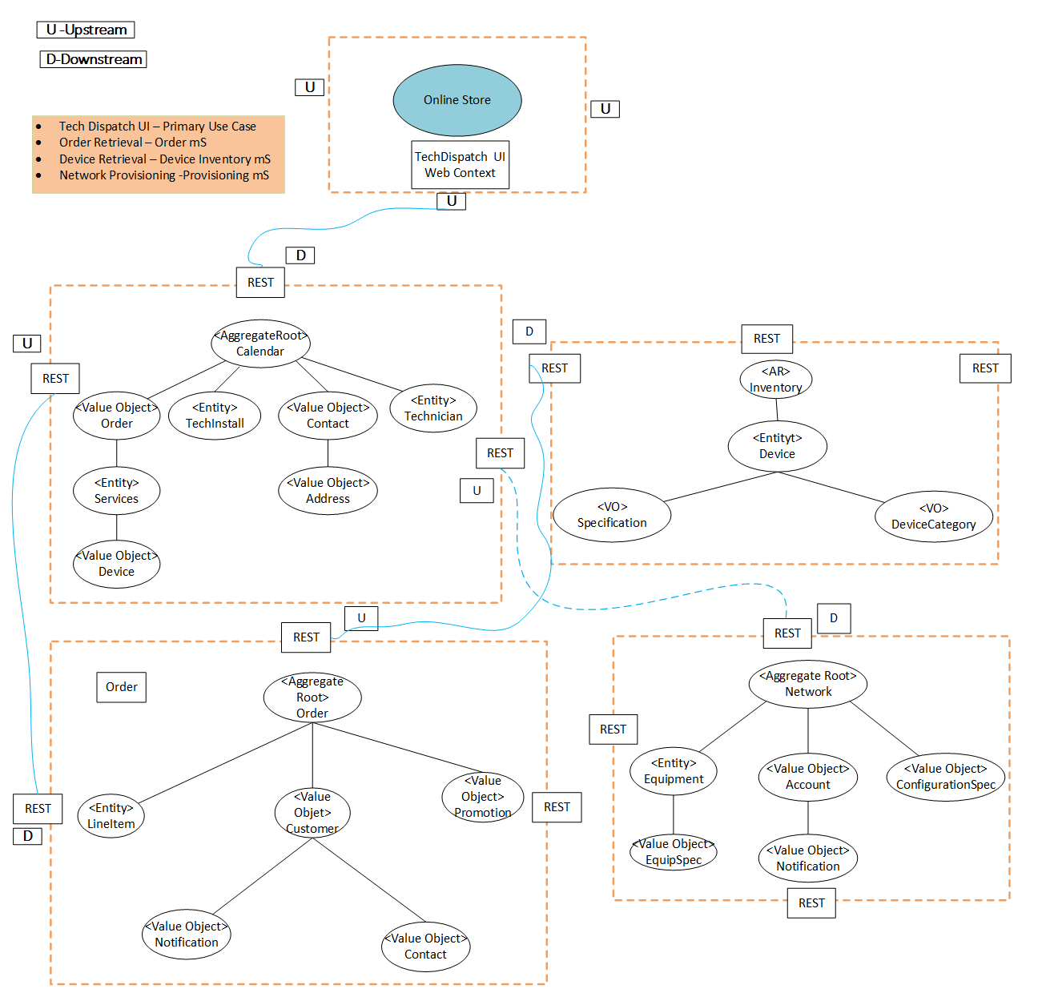

#### 3.2.12 “Store Front/Shopping Cart” Business Capabilities & SoR implementation

**Function:**

**Store Front:** System will support customer purchase, **Order Confirmation**, **cart** function, **shipping costs** and **payment options**

|  |  |
| --- | --- |
| **Concept** | **Purpose** |
| Cart | Where the order item is added |
| Checkout | Guest or Registered user submitting order |
| Address | Service, Shipping & Billing Address |
| Address gateway | Validation of Service, Shipping & Billing address |
| Shipping Cost | Cost to deliver the device |
| Tax | Estimated tax |
| Order Confirmation | Confirmation on items and prices |
| Payment Options | Prepaid, Postpaid, A/R, Credit card etc. |
| Notification | Notification sent to contact eMail |

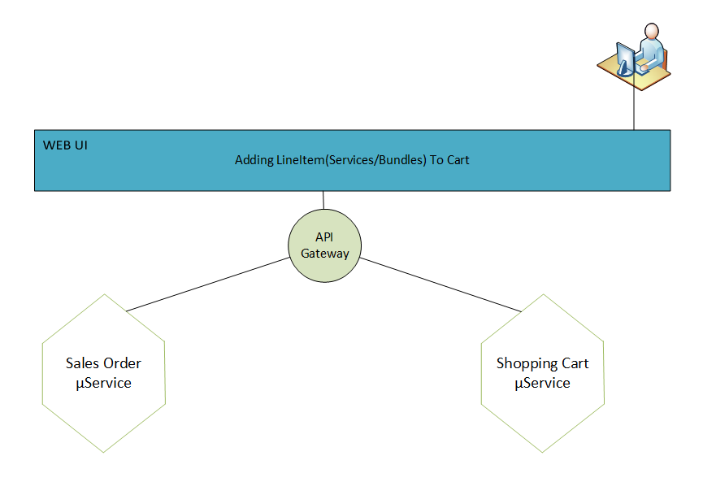

**CRUD Operations involving this domain:**

* CRUD Cart
* CRUD Checkout

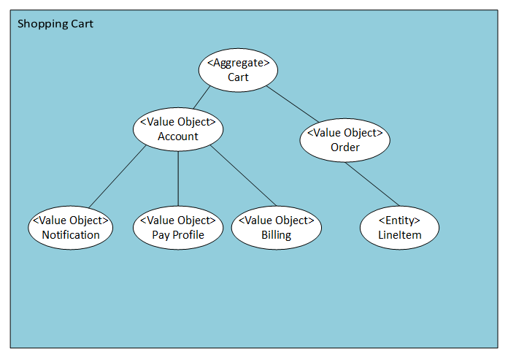

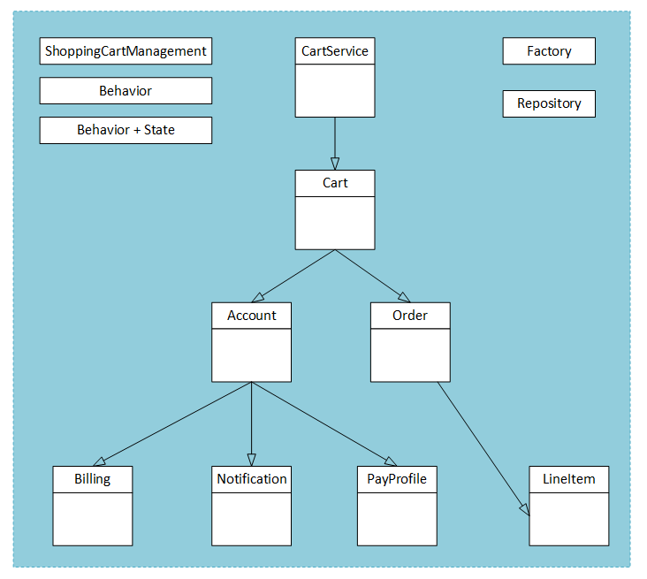

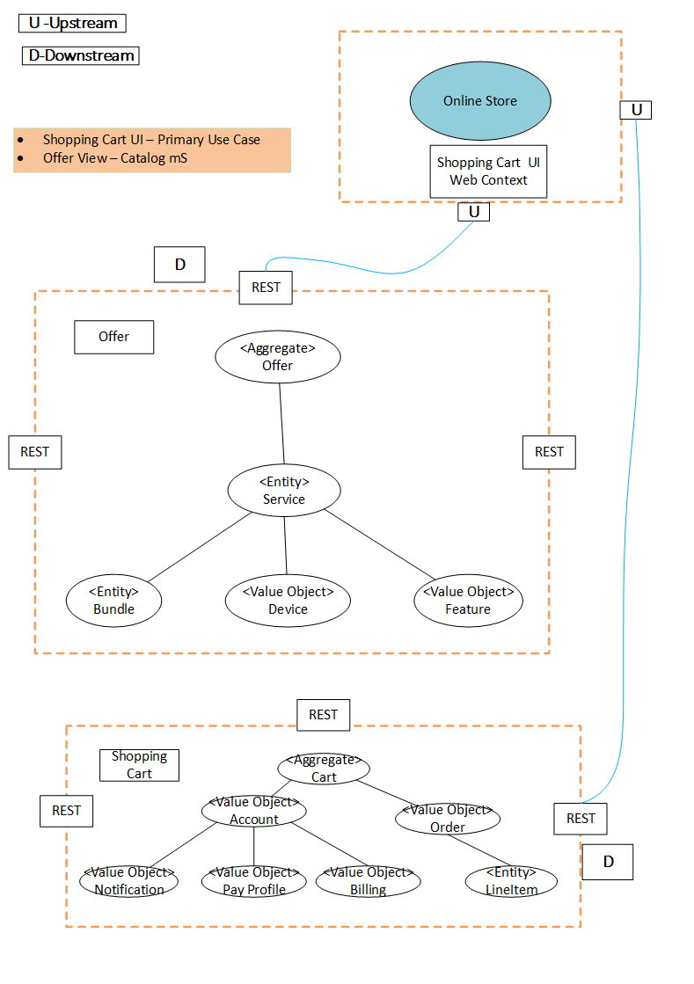

### 3.1.2 Example Store-Front Application

“Getting service boundaries wrong can result in having to make lots of changes in service-service collaboration. An expensive operation.” --Sam Newman, “Building Microservices”

|  |  |  |
| --- | --- | --- |
| STEPS | Activity/Task Performed | mS |
|  | Searching for services for the location/places a Client interested in | OfferCatalogService mS |
|  | Select Offers and add in the Cart | ShoppingCartService mS |
|  | For Checking Out and Bill Pay, sign into the account for existing client | ManageAccountServiceService mS |
|  | For Existing Addresses, select the shipping/billing address OR create new | AddressManagementService mS |
|  | Select the pay method , e.g, Credit Card, PayPal etc. | ManagePaymentProfile mS |
|  | Paying the Bill | ManagePayment mS |
|  | Generate Invoice and Order Submission, Notify Client about the Order Number and Invoice | ManageOrderService and ManageBillService mSs. |
|  | Fulfillment | ManageShippingService mS |

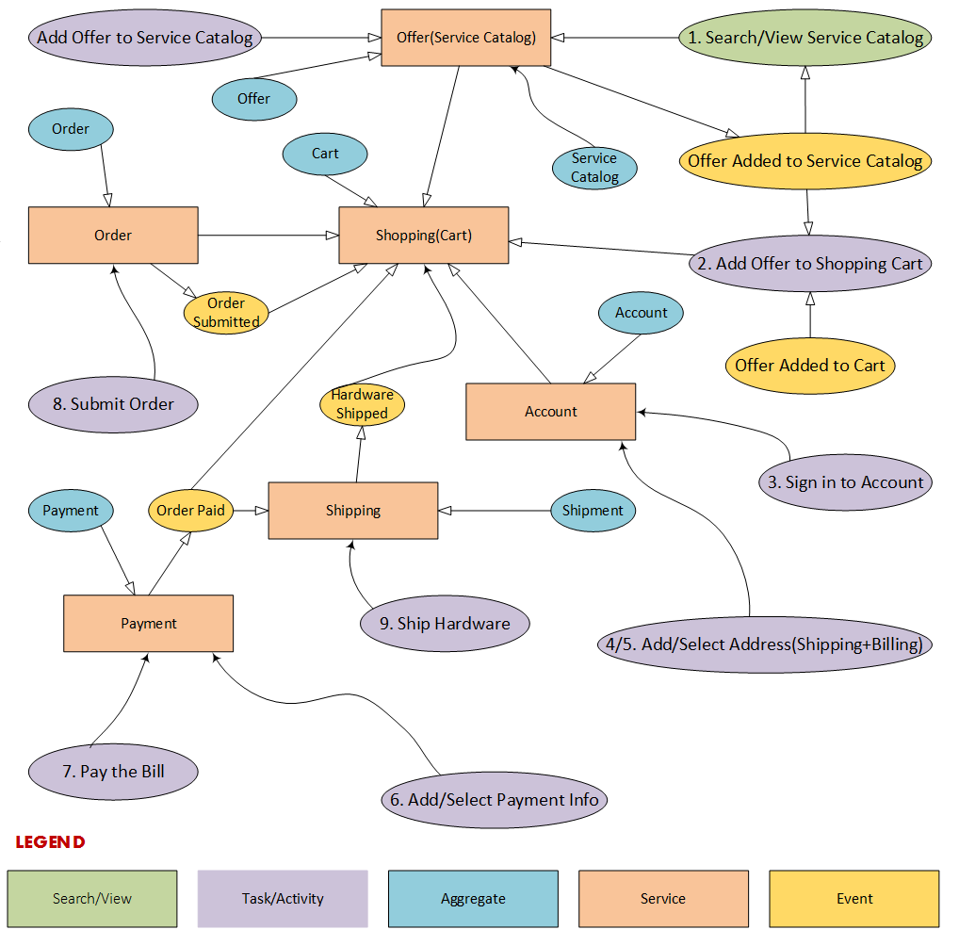

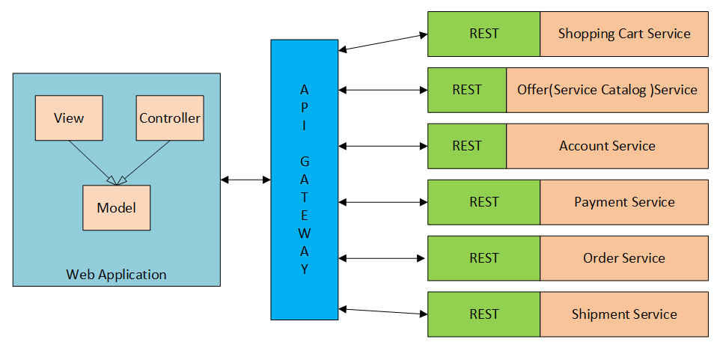

### 3.1.3 Shared Data across Micro Services and SoR

The mS encapsulation of the ‘System of Record’ data within in the database does not share data other micro services. It ensures ‘data integrity’ is maintained. The mS will own the data it operates and manipulates for its client.

The following diagrams will show common ‘elements’ shared across domains and ownership of the data element.

#### 3.1.3.1 Shared Data

Shared data used across domains.

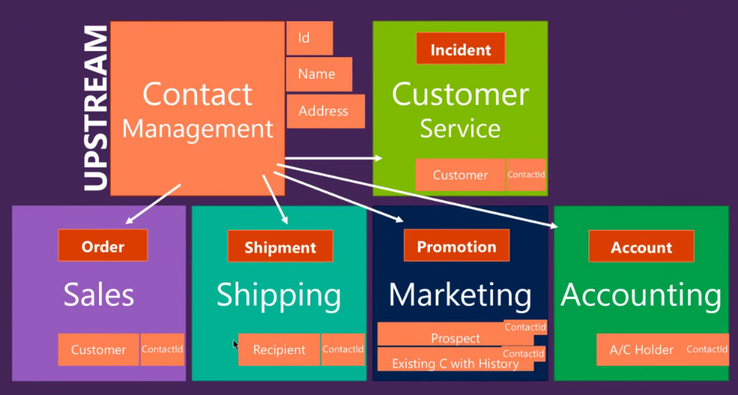

Only ‘contactId’ is shared to communicate with Customer Service, Shipping, Marketing and Accounting (Billing). The data is owned by Contact management.

The below figure shows three different business context. One owns the contact data for full “CRUD” operation; the other two are read and read+update.

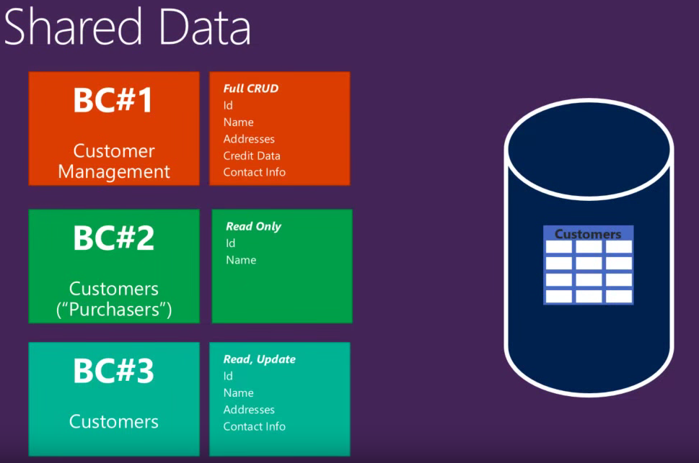

Business Context #3 can update the data in Business Context #1 by calling their services and invoking the update operation. This updates the data in the same database as the CRUD operation for ‘Contact Management’.

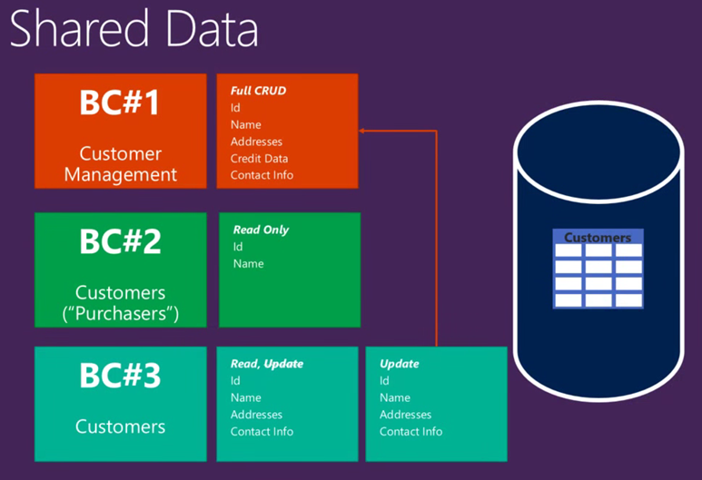

This diagram depicts independent business context’s independent DB Schema where customer date is replicated.

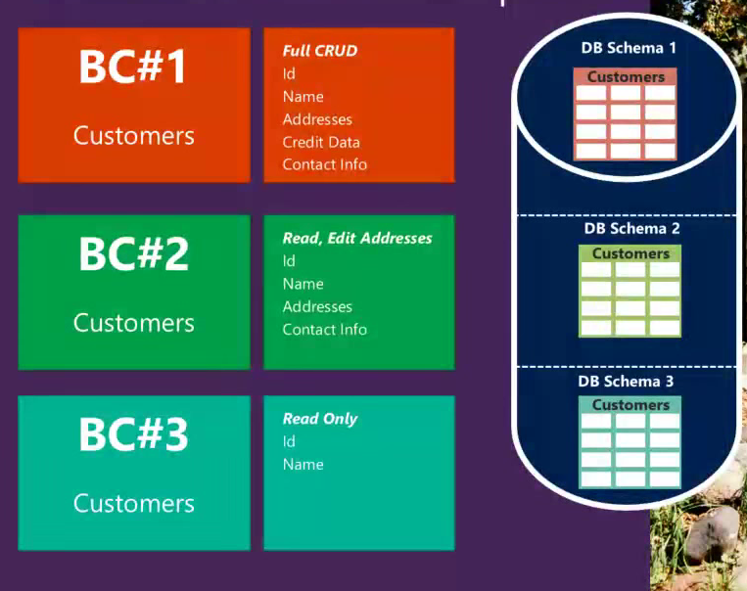

Data can be persisted and used from different business domain when necessary.

## 3.2 Integration mSs (Integration Tier)

Integration layer mS performs some form of orchestration of service provider’s mS and implements the business logic. These are grouped with broader business domain operation related to particular business.

This diagram reflects integration mS’s and the way it interacts with other systems/ms’s.

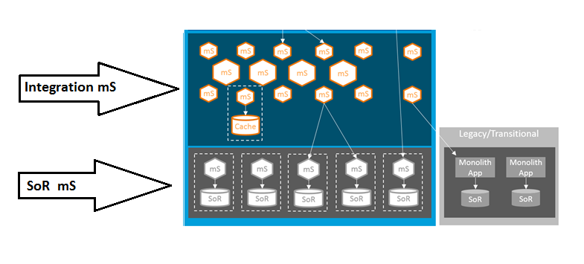

## 3.3 Presentation mSs (Presentation Tiers)

Presentation mS are built to maintain the continuity of the business flow in the presentation layer of an application. These services will represent a broader business operation domain which in turn may call multiple integration layer micro services.

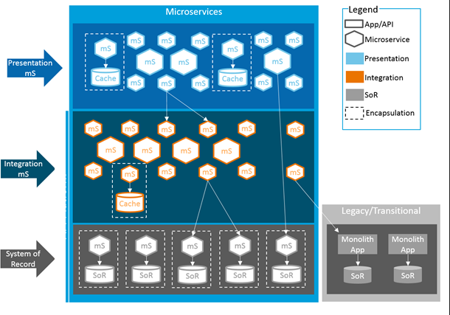

# **4 SoR mS and Bounded Context**

The following are characteristics and principles of reusability, control and resiliency.

“If our service boundaries align to the bounded contexts in our domain, and our microservices represent those bounded contexts, we are off to an excellent start in ensuring that our microservices are loosely coupled and strongly cohesive.”

--- Sam Newman

If the DDD and bounded contexts approaches, the chances of two micro services sharing a model and the corresponding data space, or ending up having tight coupling, are much lower.

“Bounded context should be as big as it needs to be in order to fully express its complete ubiquitous language.”

—Vaughn Vernon, author of *Implementing Domain–Driven Design*

According to Vernon, the size of a bounded context cannot arbitrarily reduce because its optimal size is determined by the business context (model).

Sam Newman notes in his book:

You should be thinking not in terms of data that is shared, but about the capabilities those contexts provide [...]. I have seen too often that thinking about data leads to anemic, CRUD-based (create, read, update, delete) services. So ask first “What does this context do?” and then “So what data does it need to do that?”

—Sam Newman, author of *Building Microservices*

Capabilities-centric design is more suitable for microservices than a more traditional, data-centric design.

Right Sizing API:

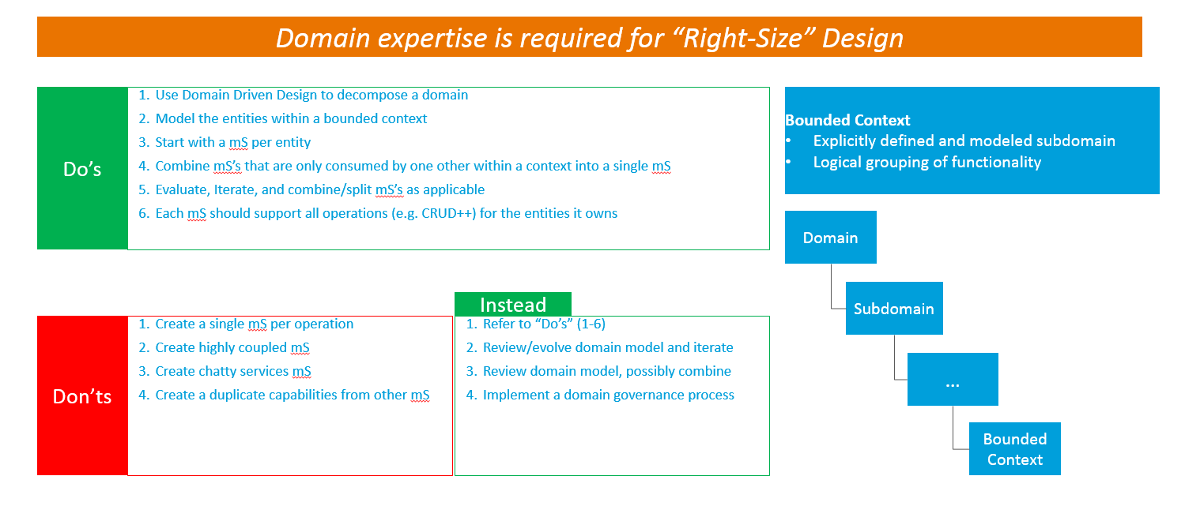

*Designing services to hide and insulate logic and data from others*

Keys to Encapsulation:

* 1. Well-defined interface contracts
  2. mS’s own their own data and logic
  3. There can only be a single owner

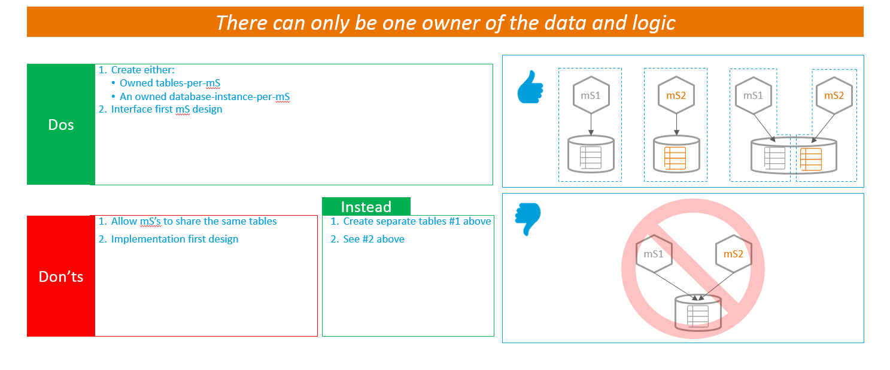

## Solution Space, new mS Design

Each bounded context lives in isolation. One bounded context is attached to other with common types (e.g., different id’s of entity) and allows for information exchange. Below is a sample “OrderMangement” mS and its design.

The sales domain order will have below activities:

* This service will represent an Order.
* This service will add AT&T products in the order
* This service will show price of the products
* This service will show device associated to provide AT&T service
* This service will show ‘promotion’ if any for the clients

The following diagram depicts two mSs [Order Management & Service catalog] working together to display the services/bundles for client to browse:

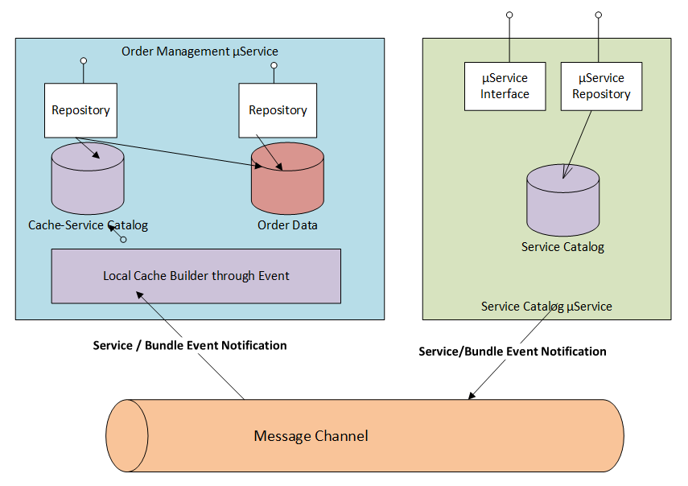

**Domain Building Blocks are:**

* Aggregate Root
* Entities
* Value Objects

**Order Aggregate Root:**

Candidates: Customer, Service(Product)

Entity + Repository = Aggregate

**Shared Data:**

Bounded Context#1: Customer Management

Full CRUD

* Id
* Name
* Address
* Credit Dta
* Contact Info

Bounded Context#2: Customers(Purchaser—Accounting Domain)

Read Only Customer Information

* Id
* Name

Bounded Context#3: Customers(Shipping Domain)

Read, Update[Update can use #1]

* Id
* Name
* Address
* Contact

Context implementation that completes the order execution:

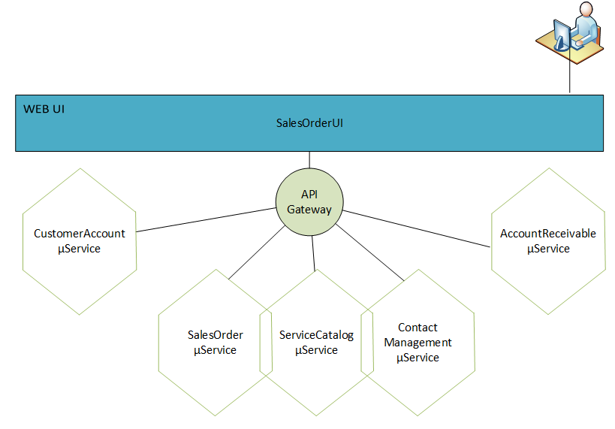

* 1. AccountReceivableBoundedContext
  2. ContactManagementBoundedContext
  3. MarketingBoundedBoundedContext
  4. Service/Bundle CRUD Domain
  5. SalesOrderBoundedContext

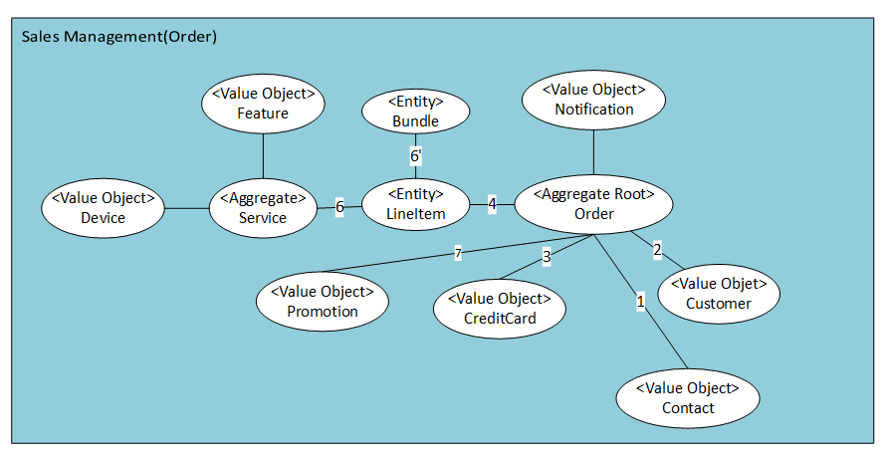

* 1. SalesDomainModel
     1. Contact
     2. Customer
     3. CustomerCreditCard
     4. LineItem
     5. Order
     6. Product
     7. Promotion
  2. SalesOrder
  3. OrderAggregateContext
  4. OrderAggregateRepo
  5. ReferenceDataContext

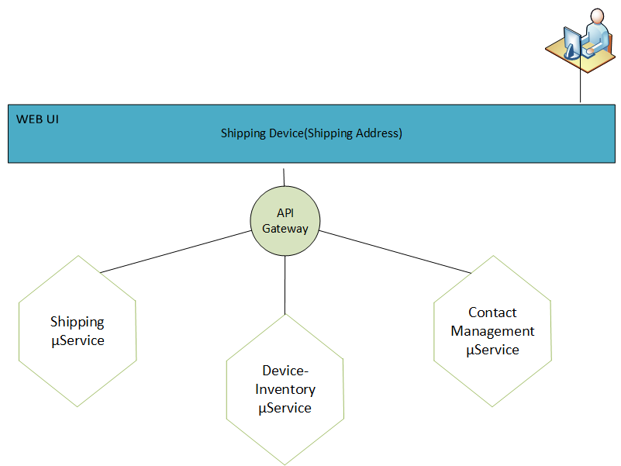

For a RESTful implementation:

|  |  |  |  |
| --- | --- | --- | --- |
| **Method** | **URI** | **Action** | **Step** |
| POST | /orders | Create New Order | 1 |
| POST/PATCH | /orders/{id} | Update the Order | 2 |
| DELETE | /orders/{id} | Cancel Order | 3 |
| PUT | /orders/{id}/payment | Pay Order | 4 |
| GET | /orders/{id} | Poll Order State | 5 |
| GET | /orders/{id}/receipt | Access Receipt |  |
| DELETE | /orders/{id}/receipt | End the Order Process | 6 |

# **5 Patterns 5/6 and mS**

Below sections will discuss mS and Pattern 5/6.

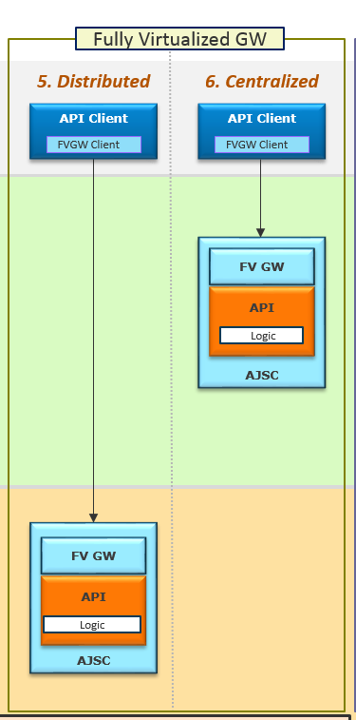

Pattern 5 & 6 and mS

Pattern 5 or 6 can be used to build RESTful mS using AJSC6 platform. mS can have CRUD operations as long as the service provider database is SoR.

**6 mS Naming, Implementation and AJSC6 Platform**

It is recommended that mS should be lightweight. mS should be built as a RESTFul API. However, a SOAP or Thrift (Used by FaceBook & Tumbler) can also be used for mS development. Following is a table articulating the strengths and weaknesses of different technologies associated with architectural properties.

## 6.1 AJSC6 and mS

AT&T Java Services container (AJSC) is a framework for building both modelled and non-modelled services. It could be both, SOAP or REST. Being a framework, lot of functionalities have been standardized.

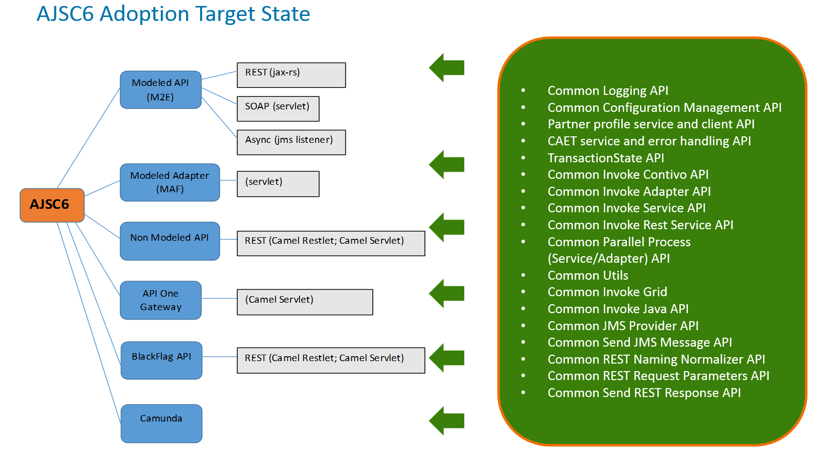

## 6.2 Framework Features

Below are given AJSC6 modeled/non-modeled features:

* Authentication and authorization (partner profile)
* REST naming normalizer
* Configuration management
* Logging (performance tracker logging, audit logging, M2E trail logging, debug logging)
* Metrics and Monitoring
* Error handling (CAET)
* Use of pre and post interceptors
* Transaction State Object serves as a vehicle to pass information between AJSC6 and modeled/non-modeled framework

## 6.3 AJSC6 Platform Seed Templates

The ‘Seed Template’ provides the base structure for development of an application/mS. Including creating the project folder structure for mS development, base configuration files, Project Object Model ‘pom’ files etc.

Maven tool is used for build, project configuration, and deployment. Maven Archetypes are used when creating AJSC6 service projects. Different archetypes are available based on project structure (operations or bundle). Once the project structure for AJSC6 service is created, files can be updated if required. *Archetype is a Maven project templating toolkit which allows for a consistent means of generating Maven projects.*

The metadata about an archetype is stored in the archetype.xml file located in the META-INF/maven directory of its jar file.

<[archetype](https://maven.apache.org/archetype-archives/archetype-2.1/archetype-common/archetype.html#class_archetype) xmlns="http://maven.apache.org/plugins/maven-archetype-plugin/archetype/1.0.0" xmlns:xsi="http://www.w3.org/2001/XMLSchema-instance"

xsi:schemaLocation="http://maven.apache.org/plugins/maven-archetype-plugin/archetype/1.0.0 <http://maven.apache.org/xsd/archetype-1.0.0.xsd>">

<id/>

<allowPartial/>

<sources>

<[source](https://maven.apache.org/archetype-archives/archetype-2.1/archetype-common/archetype.html#class_source) encoding=.. />

</sources>

<resources>

<[resource](https://maven.apache.org/archetype-archives/archetype-2.1/archetype-common/archetype.html#class_resource) encoding=.. filtered=.. />

</resources>

<testSources>

<[source](https://maven.apache.org/archetype-archives/archetype-2.1/archetype-common/archetype.html#class_source) encoding=.. />

</testSources>

<testResources>

<[resource](https://maven.apache.org/archetype-archives/archetype-2.1/archetype-common/archetype.html#class_resource) encoding=.. filtered=.. />

</testResources>

<siteResources>

<[resource](https://maven.apache.org/archetype-archives/archetype-2.1/archetype-common/archetype.html#class_resource) encoding=.. filtered=.. />

</siteResources>

</archetype>

Archetype:

Describes the assembly layout and packaging.

|  |  |  |
| --- | --- | --- |
| **Element** | **Type** | **Description** |
| id | String | The value should be the same as the artifactId in the archetype pom.xml. |
| allowPartial | boolean | Setting this option to true makes it possible to run the archetype:create even on existing projects. **Default value is**: false. |
| sources/[source](https://maven.apache.org/archetype-archives/archetype-2.1/archetype-common/archetype.html#class_source)* | List<Source> | **(Many)** Files that will go into src/main/java. |
| resources/[resource](https://maven.apache.org/archetype-archives/archetype-2.1/archetype-common/archetype.html#class_resource)* | List<Resource> | **(Many)** Files that will go into src/main/resources. |
| testSources/[source](https://maven.apache.org/archetype-archives/archetype-2.1/archetype-common/archetype.html#class_source)* | List<Source> | **(Many)** Files that will go into src/test/java. |
| testResources/[resource](https://maven.apache.org/archetype-archives/archetype-2.1/archetype-common/archetype.html#class_resource)* | List<Resource> | **(Many)** Files that will go into src/test/resources. |
| siteResources/[resource](https://maven.apache.org/archetype-archives/archetype-2.1/archetype-common/archetype.html#class_resource)* | List<Resource> | **(Many)** Files that will go into src/site. |

Source describes a source file. Note that source files are always filtered, unlike resources that can be non-filtered.

**Element Content:** The source file.

|  |  |  |
| --- | --- | --- |
| **Attribute** | **Type** | **Description** |
| encoding | String | The encoding to be used when reading/writing this file. Platform encoding is used by default, or ISO-8859-1 when filename ends in .properties |

Resource

Describes a resource file.

**Element Content:** The resource file.

|  |  |  |
| --- | --- | --- |
| **Attribute** | **Type** | **Description** |
| encoding | String | The encoding to be used when reading/writing this file. Platform encoding is used by default, or ISO-8859-1 when filename ends in .properties |
| filtered | boolean | A resource can be filtered, which means the file will be used as Velocity template. It can be non-filtered, which means the file will be copied without modification. **Default value is**: true. |

Example Template Attributes for AJSC6:– Template Attributes are dynamic and will differ according to which seed template is selected.

**Service Name**: The Service Name will be the ArtifactID of the Maven project. User-defined, **use lowercase letters and no strange symbols**. The ArtifactID will be used to create the repository and the Jenkins job.  
For more information, please visit: <https://maven.apache.org/guides/mini/guide-naming-conventions.html>.

**Service Group**: The GroupID of the Maven project, GroupID will uniquely identify your project across all projects (that is, com.att.ajsc).  This should be your AAF namespace.  
For more information, please visit: <https://maven.apache.org/guides/mini/guide-naming-conventions.html>.

The format of the Service Group name corresponds with the AAF namespace that the generate process will use in the background (i.e. service group com.att.oms would use a namespace of com-att-oms).  **The Service Group namespace value should match what was previously onboarded/requested as part of the Prerequisite steps.**

**Service Package**: Defines the source package folder.  Generally this value would be the Service Group plus an optional additional component (that is, com.att.ajsc.demo).

**Context Root**: Context root of the generated service.

**Creation of mS from Seed Template:**

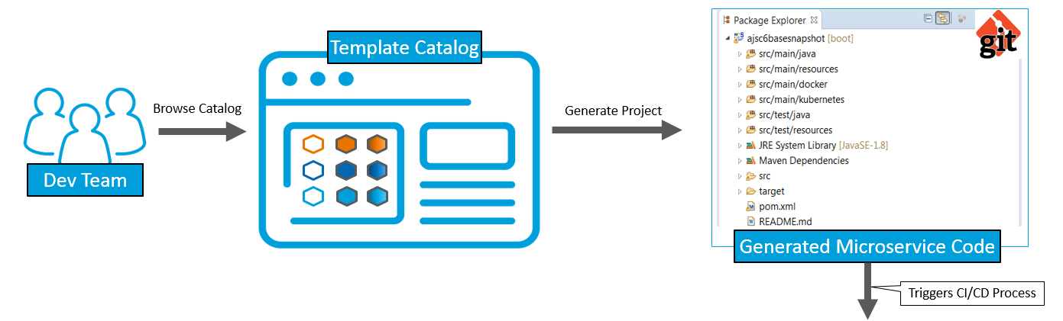

Seed templates provided for AJSC6 Platform are given below:

### AJSC-M2E Templates

1) Multi service (xpdl) mS (bundle)

Create bundle, bundlebase, servicebase using bundle template: AJSC6_MODELED

Create each service using one of the service templates (these are non-deployable unit to be included in the mS): AJSC6_MODELEDREST | AJSC6_MODELEDSOAP | AJSC6_MODELEDASYNC | AJSC6_MODELEDRESTASYNC (for stateful only) | AJSC6_MODELEDSOAPASYNC (for stateful only)

2) Standalone service

Create service, service base using one of the single service templates: AJSC6_MODELEDREST_STANDALONE | AJSC6_MODELEDSOAP_STANDALONE | AJSC6_MODELEDASYNC_STANDALONE

### AJSC-NONMODELED Templates

Choose one of the flavors from the following templates: AJSC6_NONMODELEDSERVLET (using Camel Servlet, xml based route) | AJSC6_NONMODELEDCXF (using JAX-RS, java based route) | AJSC6_NONMODELEDRESTLET (using Restlet)

### AJSC-MAF Template

Use the following template to create adapter mS (bundle): AJSC_MAF

(Creating individual adapter project (these are non-deployable unit to be included in the mS) will be BAU using existing MAF wizards)

## 6.4 CSI DB, CSI Dashboard, CS BOBPM DB

There are some databases used for CSI Sub-Applications including BPM for reference data, state preservation for service communication, business data, audit, process information. This is needed to provide support for the business rules implementation etc. other than CDF, LDAP storage systems.

They will not be impacted during the AJSC6 bundle migration process.

## 6.5 Common Data Model Restructuring (CDMR)

The APIs should be reorganize to allow for more mS using the mS tooling/concepts without impacting clients.

The mS bundle will have API(s) within it. Each mS bundle with its own APIs and CDMR service application will allow the unit to be schema, versioned, developed, deployed, and delivered independently and continuously. These are AJSC 6.0 bundles. Since it is its own CDMR service application, it would also have its own toolkit.

In short, for mS migration

1. Each Bounded Context is a mS and is set of related services on same entity (like Account)
2. Define a new CDMR service application name each Bounded Context
3. Each Bounded Context will have its own new bundle and the name of the bundle should be the mS name
4. The new bundle needs to run in AJSC 6.0

### 6.5.1 Service Namespace Change

Namespace change examples are given below:

* Old
  + CSI/Types/Public/MessageHeader.xsd
  + CSI/Types/Public/SoapFault.xsd
  + CSI/Types/Public/CingularDataModel.xsd
  + CSI/Types/Public/ErrorResponse.xsd
  + CSI/Container/Public/AddWirelineTroubleReportRequest.xsd
  + CSI/Container/Public/AddWirelineTroubleReportResponse.xsd
* New
  + CSI/**TroubleManagement**/**InfrastructureCommon**/Types/Public/MessageHeader.xsd
  + CSI/**TroubleManagement**/**InfrastructureCommon**/Types/Public/SoapFault.xsd
  + CSI/**TroubleManagement**/**InfrastructureCommon**/Types/Public/ErrorResponse.xsd
  + CSI/**TroubleManagement**/Types/Public/CommonDataModel.xsd
  + **Future**:CSI/**TroubleManagement**/Container/Public/AddWirelineTroubleReportRequest.xsd
  + **Future**:CSI/**TroubleManagement**/Container/Public/AddWirelineTroubleReportResponse.xsd

### 6.5.2 Adapter Schema structure change

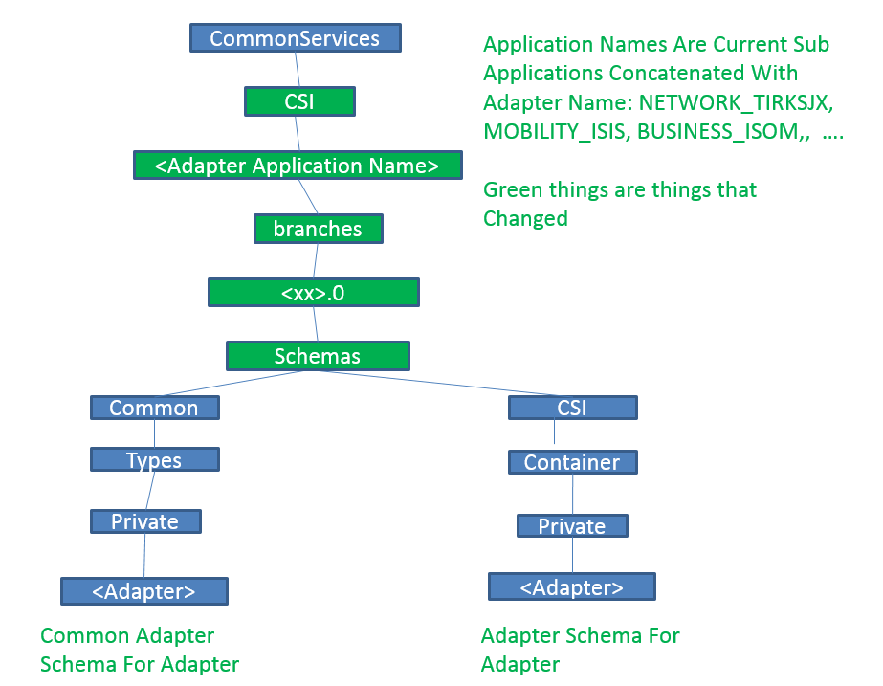

## 6.6 Modeled SOAP and REST API (M2E) as mSs

* Eclipse with Spring Tool Suite
* Run M2E service as spring boot application
* Test with Postman or HttpRequester
* No need to register M2E service as DME2 service endpoint
* No need to run API with Docker and Kubernetes

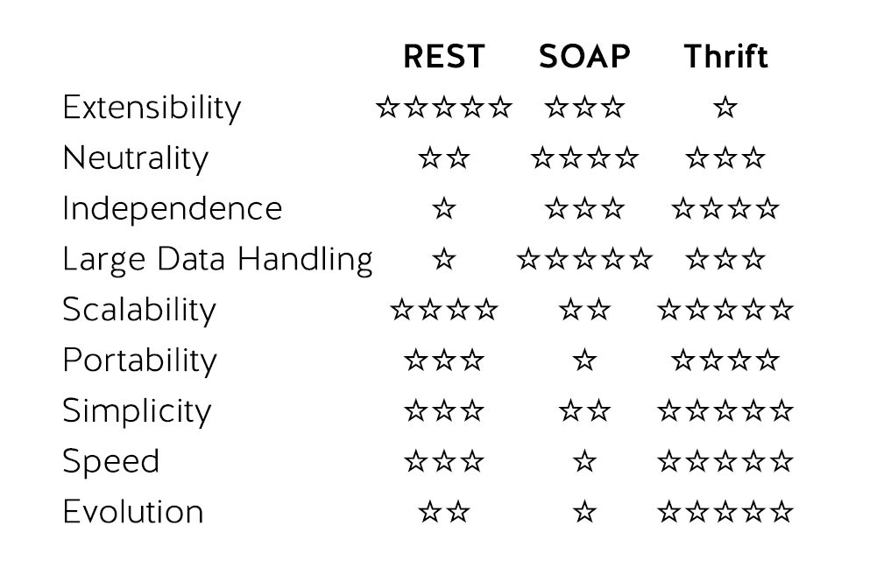

## 6.7 mSNaming Conventions

The following are examples of Naming Conventions: [mS Naming Standard](https://tspace.web.att.com/files/app/file/7222ffd1-ca0e-497a-bbba-a3500a28a2f2)

mS names are FQDNs generally conformant to a fully qualifies Java class name. That is all lowercase letters and numbers that are dot “.” separated for name space parts followed by a dot separated camel case name. No namespace or Name can start with a number.

**Good Examples MS Names:**

com.att.csi.cc.AccountProfile

com.att.csi.**custcare**.AccountProfile // More descriptive name

com.att.csi.cc.account.Profile // Assuming a plan for more services under cc.account

com.att.aft.infra.LoggingSvc

com.att.abs.b2b.MsgSvc // Digit 2 allowed iff it is not the 1st character of any segment

**BAD Examples MS Names:**

com.att.Profile // Unlikely at this high level of the tree!

com.att.csi.**CustCare**.AccountProfile // Namespaces should be in lower case

com.att.csi.**cust-care**.AccountProfile // Only lower case letters and numbers in FQDNs

com.att.fin.**2muchfun**.Payments // No digit as a first character

**Goals:**

1. Create meaningful names that follow commonly understood conventions to IT professionals.
2. Create FQDNs suitable for most compilation and automation tooling. E.g.
   1. The same FQDN in the MS catalog and GRM directories for DME enabled MSs
   2. Integrate well with Docker, K8
   3. Integrate well with language bindings like Java, WADL…
3. Create ns (Namespace) hierarchies that
   1. Convey subject matter semantic meaning for humans
   2. Capture as well as possible business domain/ownership/MOTS identity
   3. **Provide good points to apply hierarchical administrative security roles.**  E.g. one would need the owner’s permission to add something to the namespace com.att.csi.cc.
4. Create **unique** fully qualified names for services while allowing for Name reuse. E.g.
   1. **com.att.cc.postal.Address**
   2. **com.att.network.ip.Address**

Unique FQDNs permit unambiguous automation while permitting humans to use the common names like “Address” freely within their context.

1. Make service names easily searchable in the catalog, GRM or other tools using minimum qualification. E.g. a search for “Address” from the above example should return both FQDNs, where a search for “ip.Address” just one.

**Specification:**

*Microservice* ***FQDN:==com.att.<ns>.1-n<Name>***

1. *The naming guidelines assumes “****com.att****” as a literal beginning of internal MS names. Other literals are possible but require an exception*
   1. *com.<vendor>… // For vendor MSs*
   2. *org.<org>… // For some open source services*
   3. *com.<subsidiary> // E.g. com.dtv*
2. ***<ns>:== <a-z>1-n<a-z 0-9>0-n*** *// Lower case letters & numbers, abbreviations are often best*
3. ***<Name> :==<<A-Z>n<a-z A-Z 0-9>n>n*** *// Camel case name. e.g. AccountProfile, TNPortSvc*

TAM without Business Entity(Track).

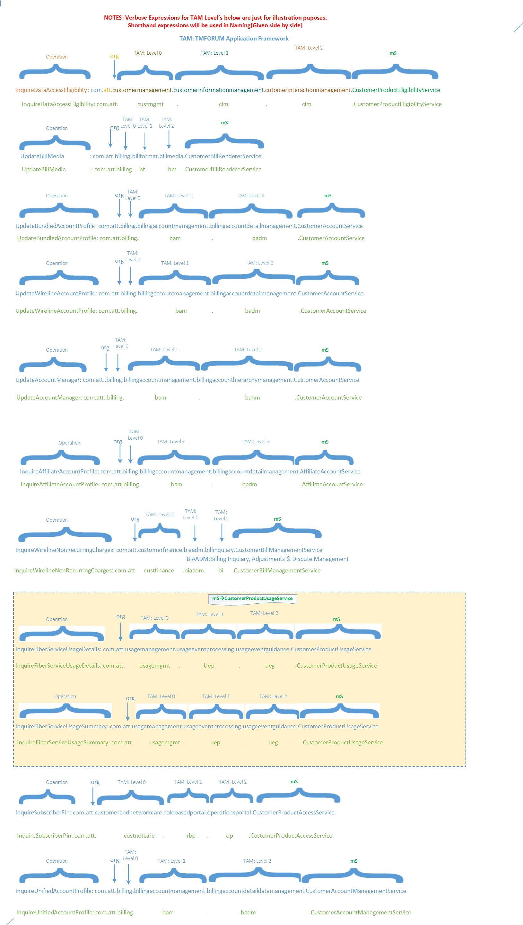

Example with Business Entity(Track):

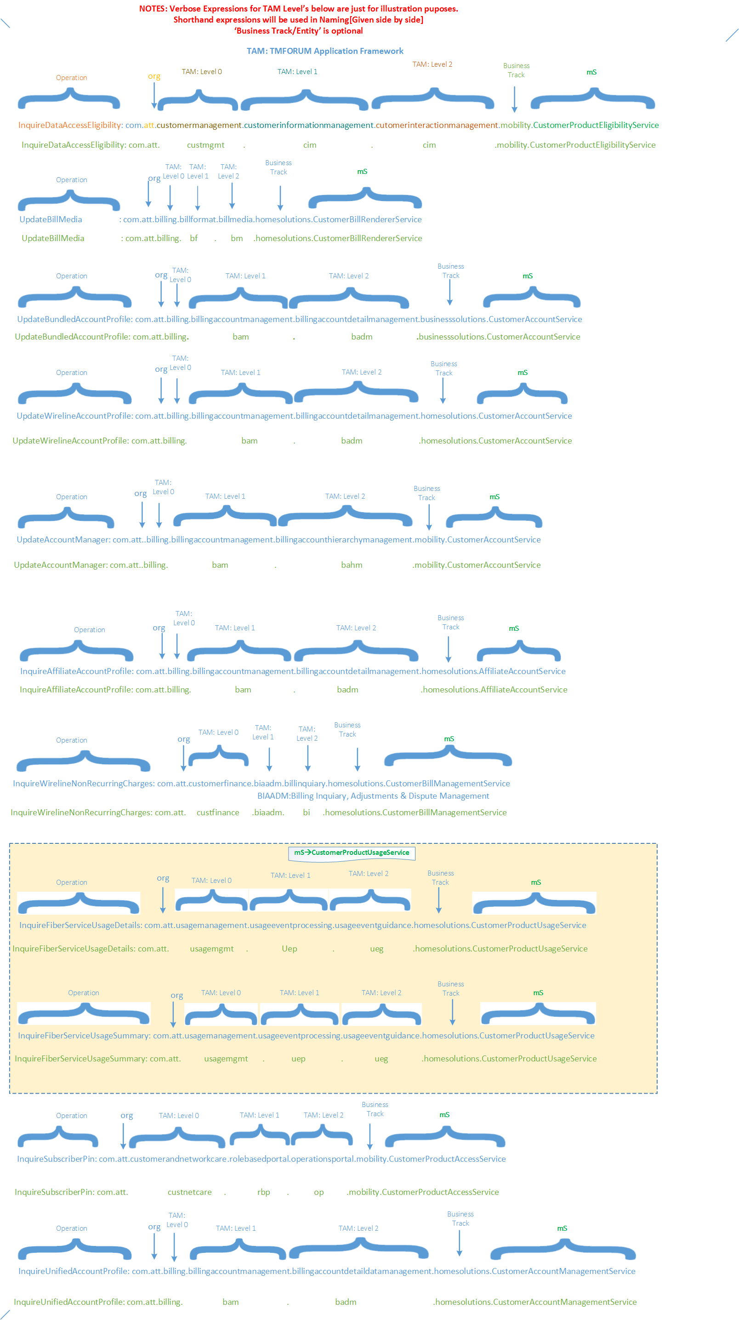

**7 mS Design Principles, Patterns & Anti Patterns**

## 7.1 Principles Definition

The following principles outline key characteristics that define a micro service.  All mS are APIs but not all APIs are micro services.

|  | **Principle** | **Description** |
| --- | --- | --- |
| 1 | **Single capability focused** | The mS architectural style composes applications from separate, independent services that provide a single domain capability.  This allows parts of the application to be changed and evolve over time without impacting other parts of the application. There is no hard requirement on the size of a mS. Keep the service as lightweight as possible while still fulfilling the business requirements for the “single capability”.  mS are agile so services should be easily maintainable by small agile teams.  The agile guidelines advises team sizes between 5-9 members. |
| 2 | **Independence** | This principle applies all aspects of mS delivery.  mS must be independently developed, tested, deployed, configured, upgraded, scaled, monitored, and administered.  In particular, independently deployable is a fundamental capability.  mS must be standalone executable processes.  They cannot be deployed within “Application Servers” alongside other services. |
| 3 | **Encapsulation** | mS must hide implementation details.  This insulates mS consumers from changes either within or downstream from the services they consume. As part of encapsulation, mS must keep persistent data private to the service and accessible only via its API.  In other words, mS must not integrate at the data layer.  This means mS must not share the same database or database schema with other services. |
| 4 | **Automation** | Automation applies to all aspects of a MS.  Automation means embracing DevOps and continuous integration and delivery processes (CI/CD).  This includes:   * Automated Testing * Automated Deployment * Automated Scaling * Zero-Touch Rolling upgrades/downgrades |
| 5 | **Consumer First** | Consumer First is about making it as simple and easy as possible for the consumers of mS to successfully use it.  This includes human consumable documentation, programmatic metadata (e.g., WSDL/XSD, [Open API](https://openapis.org/)), and mechanized tools for service discovery and routing to the service (see Principle #10).  The documentation includes a catalog of APIs with the details of how to call them. |
| 6 | **Highly Observable** | Provides insight and understanding of how request paths are processed and flow across services.  Since large applications consist of many distributed services there is a need to collect, aggregate, and analyze logs and metrics across all services. It’s important to follow logging standards that provide ways to correlate requests through the service flow and be able to view the call chains or graphs. |
| 7 | **Highly Resilient** | Building applications as a cohesive set of services requires the ability to tolerate and gracefully handle failures of all kinds.  Services must be able to detect failures quickly and workaround them if possible. |
| 8 | **Infrastructure Agnostic** | mS must be portable and elastic.  Moving a services across hosts, datacenters, or clouds should not be a problem.  They should not be dependent on static addresses or ports when possible.  As services are taken in and out of operation, they must be able to discover their dependent services as well as be discoverable themselves. |
| 9 | **Lightweight communications protocols** | mS must follow a dumb pipe, smart endpoint approach for communication protocols.  The core requirement is that business logic cannot be implemented within the protocol or broker and all domain logic remain within the service endpoint implementations.  The protocol must be an open standard or an industry leading open source technology.  HTTP is a common choice, but lightweight event/message brokers may be acceptable. |
| 10 | **Discoverable** | Since mS are auto deployed and infrastructure agnostic, they are required to be dynamically discoverable.  Consumers must have the ability to query a service registry to lookup available instances and then route accordingly.  This also requires the service to register itself with the service registry when it becomes available. |

### 7.1.1 Domain Driven Design

* + Decomposing large domains into subdomains (problem areas)
  + Basing detailed designs on a model of the subdomain
  + Collaboration between technical and domain experts to iteratively refine the model



Business Domain

*Account*

*Inventory*

*Shopping Cart*

*Ordering*



App Data

Application

Ordering Data

Ordering mS

Cart Data

Shopping Cart mS

AccountData

AccountmS

Inventory Data

Inventory mS



### 7.1.2 Right Sizing of an Api

*Domain expertise is required for “Right-Size” Design*

The following is a guideline for right sizing:

1. Use Domain Driven Design to decompose a domain
2. Model the entities within a bounded context
3. Start with a mS per entity
4. Combine mS’s that are only consumed by one other within a context into a single mS
5. Evaluate, Iterate, and combine/split mS’s as applicable
6. Each mS should support all operations (e.g. CRUD++) for the entities it owns

Avoid the following:

1. Create a single mS per operation
2. Create highly coupled mS
3. Create chatty services mS
4. Create a duplicate capabilities from other mS

### 7.1.3 Bounded Context

The following are concepts for scoring

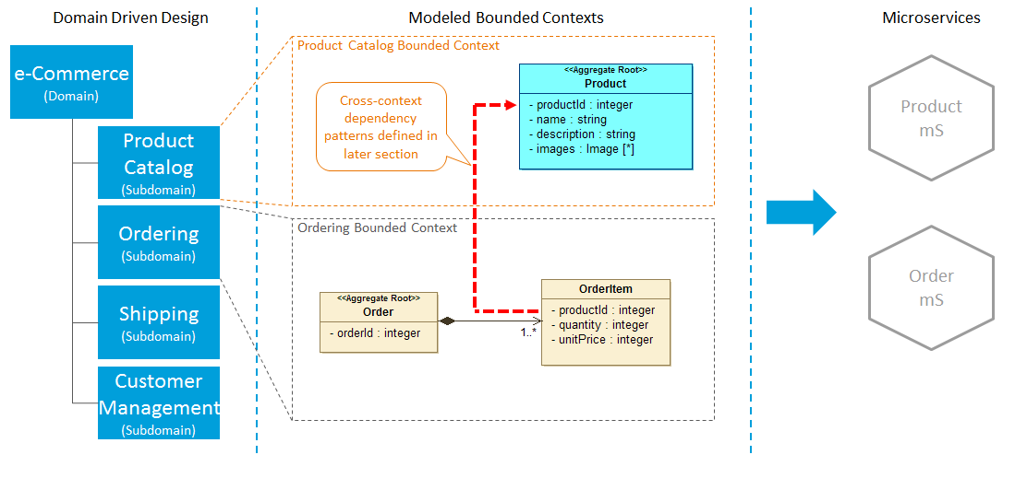

## 7.2 mS Patterns

### 7.2.1 Presentation mS

* UI/UX capability focused
* Fully encapsulated data caches
* 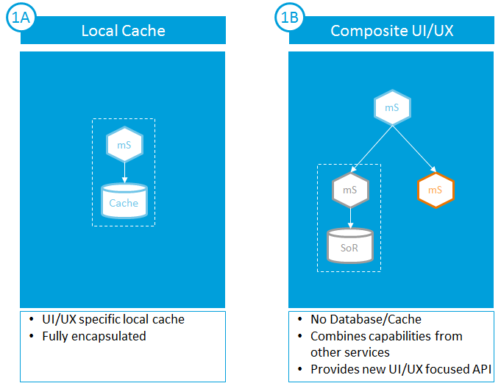

### 7.2.2 Integration mS

* + Integration capability focused
  + Do not own data
  + Composite value-add APIs

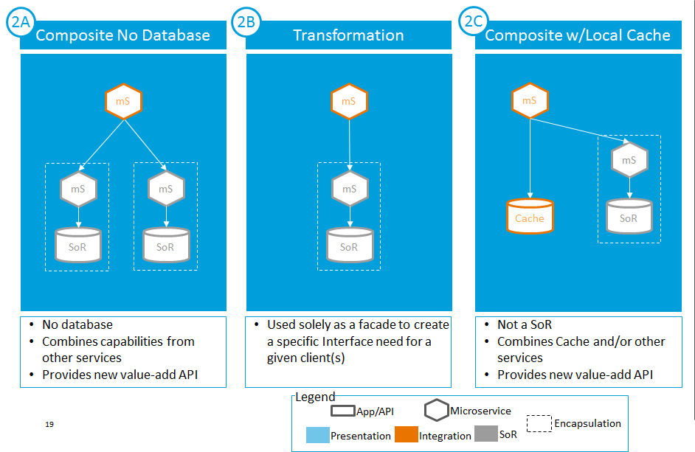

### 7.2.3 Legacy Enabling mS

* API Enable legacy capability
* Fully encapsulated functionality

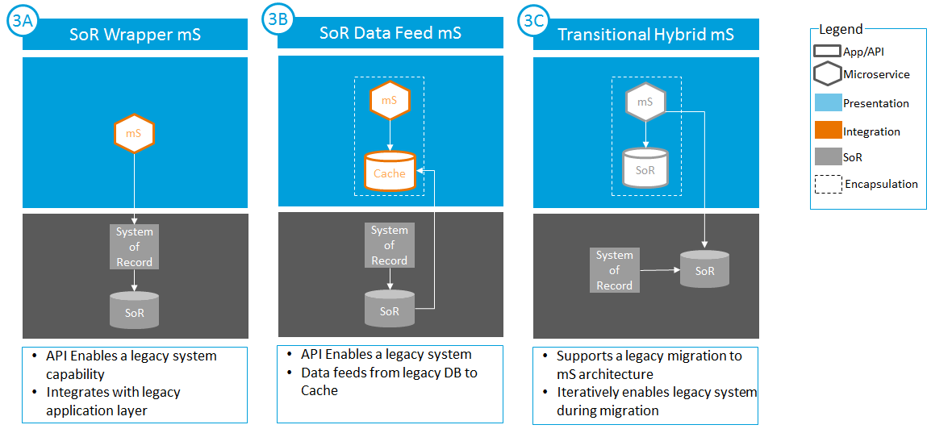

### 7.2.4 SoR mS

* System of Record
* Single Owner of data
* Fully encapsulated data per mS

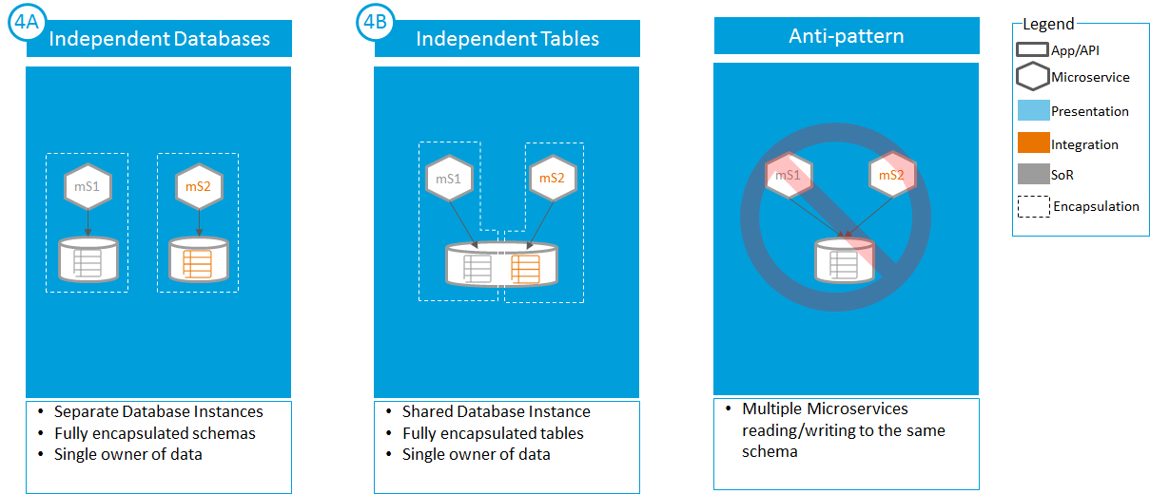

### 7.2.5 Cache Population

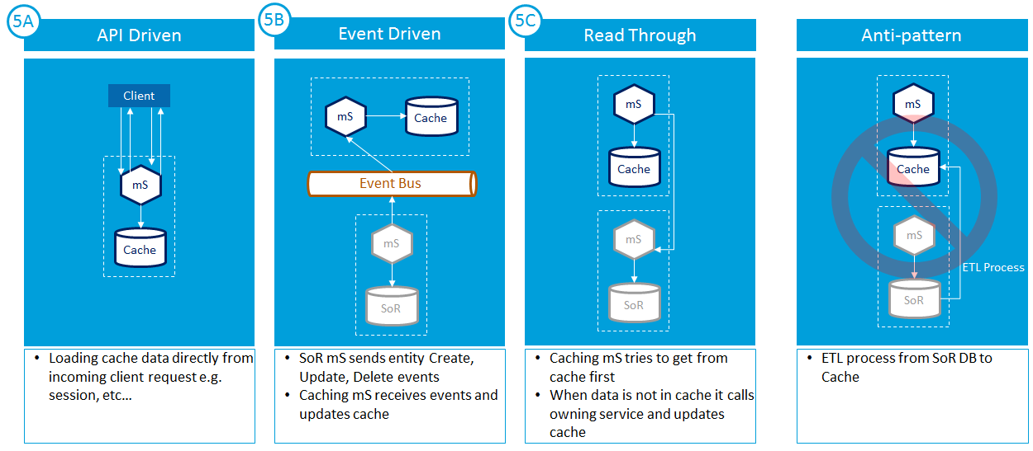

### 7.2.6 Cross-Context/Domain Dependencies

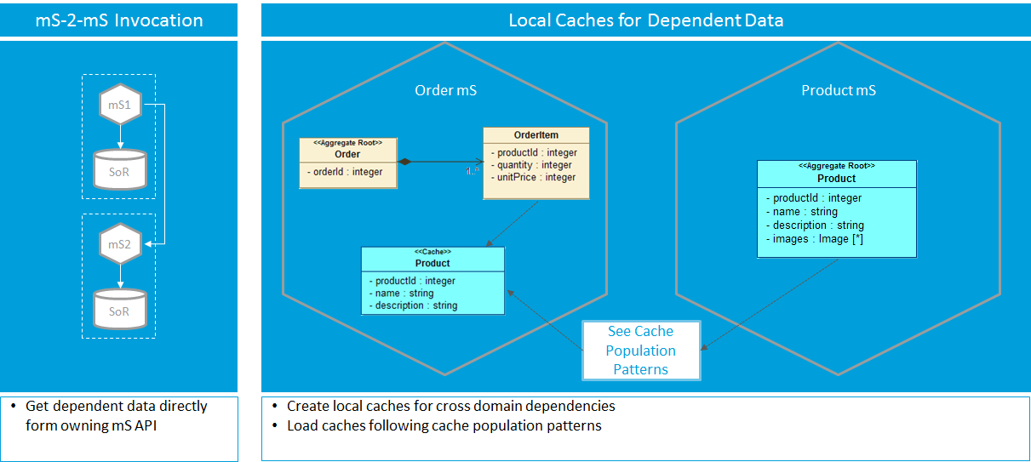

## 7.3 mS Anti Patterns/Pitfalls

Anti patterns are thought of as patterns but works counter.

### Cohesion Chaos

The mS objective is to be agile, scalable and high performance. When adding a ‘feature’ it is important to reuse existing API to avoid another API call.

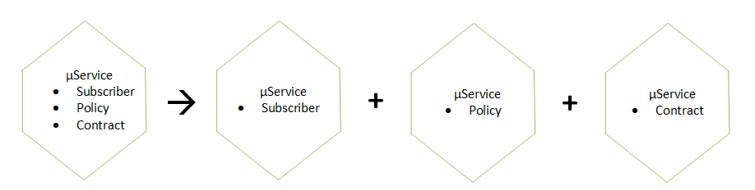

A governance team should be in place to ensure compliance for building services principles.

### Layered service architecture

All CSI modelled services are ‘integration’ layer services. On top of this are BPM layer services.

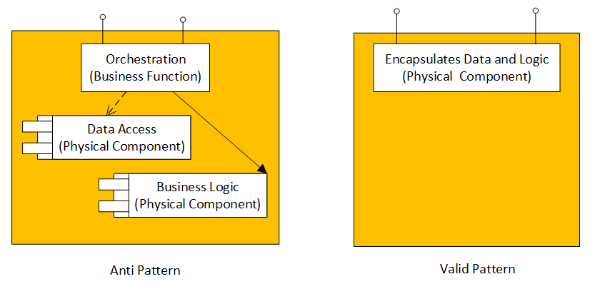

The issue with ‘layered’ service architecture is to maintain a ‘team’ for each layer, and share the business logic across all those layers. Sharing business logic obviously defeats the purpose of designing & developing mS. There are times when “Object Relational Mapping” exposes table fields to upper layer services. The changes will be propagated from lower layer to the presentation layer and all ‘horizontal’ teams are impacted. So, inherently it adds delivery complexity and runtime in-efficiencies.

### Relying on Consumer Sign-Off

‘Independence’ is one of the 10 principles. Services will be used by multiple channels, e.g., ‘Customer Care’, online, IVR etc.

If the service is not independent, a sign-off is needed from a channel which may delay the deployment of two other channel consumed by the update.

### Data Driven Migration

During migration, developer may attempt to add functionality and data migration simultaneously. That may not allow the mS to be single purpose. Additional cost, time and effort will be needed for corrections to single purpose.

It is best to start with a coarse separation of functionalities and use an iterative process to achieve the ‘Bounded Context’. It will point to a single database.

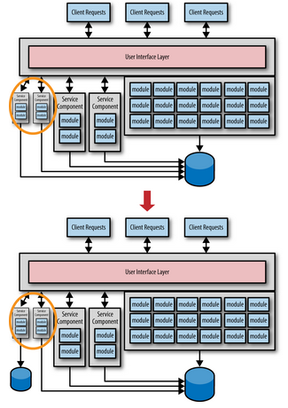

Once there is no longer movement in the functionality, partition the data ownership to aligned with the mS.

### 7.3.5 Unknown Caller/Debugging Hell Too Many Data Migration

mS uses chaining calls to other service. It requires collaboration among the chained services for debugging and support

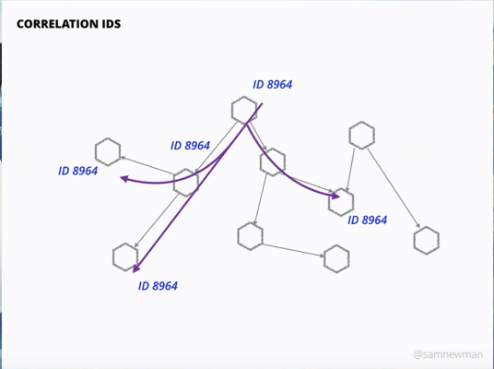

Maintaining a correlation ID across a sequence in mS calls (chaining) supports traceability and troubleshooting for the implemented mS.

### 7.3.6 Synchronous World/Timeout

There should be a balance between synchronous and asynchronous communication of our services.

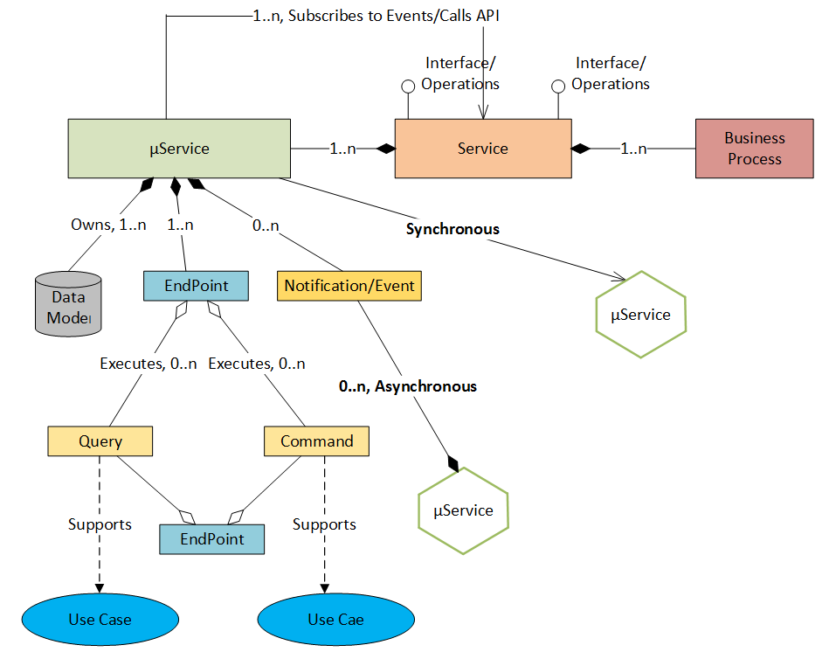

In synchronous world, if there is only one malfunctioning mS, the whole system may be compromised. Asynchronous service can avoid this situation and also provide better performance and ensures loose coupling.

### 7.3.7 Timeout/Circuit Breaker Pattern

A synchronous call timeout is implemented when a response is not received from downstream so to avoid bringing down the system.

Since mS is a distributed architecture, service availability and responsiveness is important. If the service is under a heavy load, responsiveness can degrade and may implement ‘timeout’.

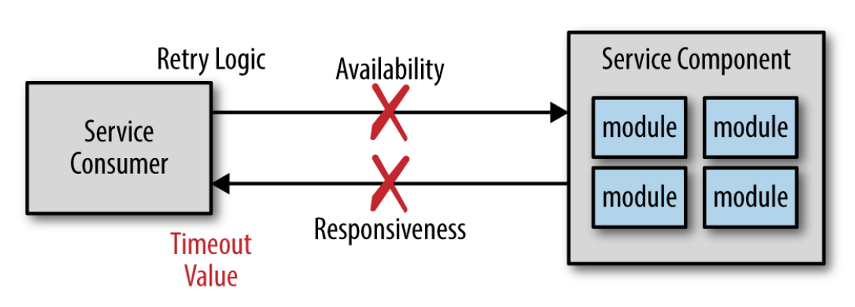

However ‘timeout’ implementation is not necessarily a bad idea. It becomes an anti-pattern when taken into account the cost of the implementation. If, for example, an average call takes 2 second and under a heavy load, it takes 5 second. If a value of 10 second is set, it will take 10 second from receive a response from downstream system.

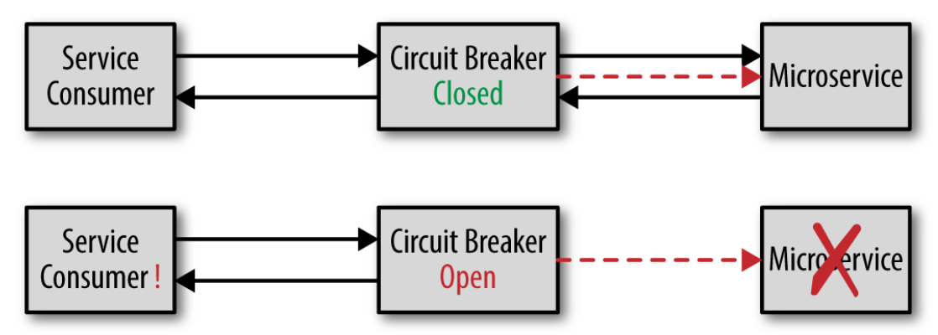

Implement circuit breaker pattern will allow a service consumer to call the as long as circuit Breaker is ‘closed’. While it is open a calling service can implement logic that handles the unavailable scenario.

### 7.3.8 Shared Data and mS

mS architecture drives to encapsulate data that it manipulates using business logic. In reality, mS is a distributed architecture and sharing will occur. However it should be kept to a minimum. The implementation should not be by sharing common schema but by making call to the data owning mS.



A smart approach of sharing common data is by replicating the shared data shown above.

### 7.3.9 Reach-in Reporting

mS data encapsulation may poses a problem for a ‘’reporting’ service. The following may address the reporting issues:

* HTTP Pull Model
  + In this case ‘Reporting’ mS will invoke all other related services over HTTP to get the data and then build the report.
* Batch Pull Model
  + A batch service will pull the data from all other relevant mSs databases and build reporting database out of that. Then build the report out of reporting database
* Database pull Model
  + A service directly gets data from the independent mSs databases and build the report out of that.
* Event-based Push Model

Following picture depicts the event based push model where the update to reporting db will be real time. It supports the Bounded Context premise for mS and provides efficiency.

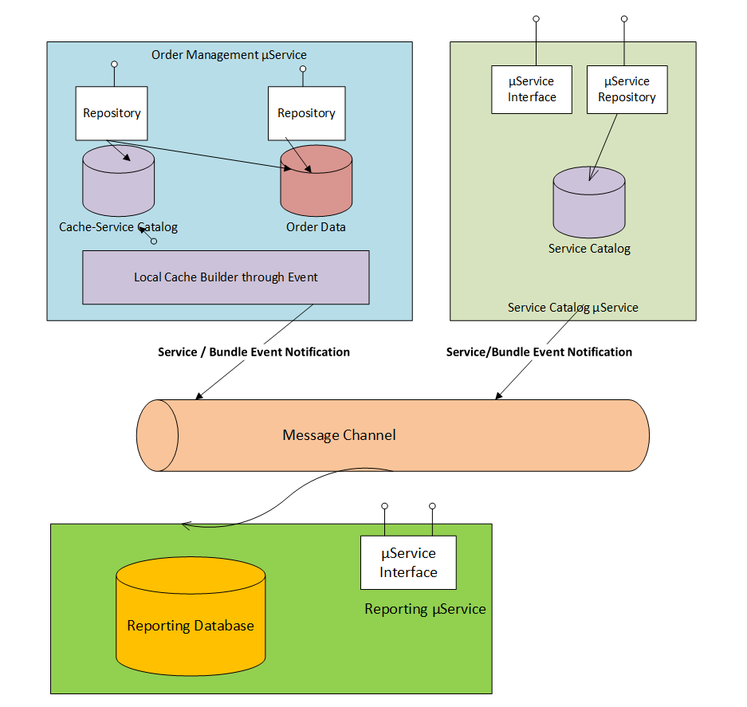

# **8 Resiliency and mS Architecture**

It is important to build resilient software. Resilience provides

* The ability to spring back into its original condition means providing normal service; Elasticity
* The capacity to recover quickly from difficulties; Toughness

It is not uncommon to experience processing failures such as database failure, load spike, malformed input that causes error etc. where quick recovery is needed. The following practices are recommended:

Design aspect:

* + Loose coupling of the components that works together so compartmentalizing it when failure occurs
  + Thread or Process pooling so load spike can easily be handled

Operation aspect:

* + Supporting redundant services so switching to healthy instance is quick
  + Automation of failover so recovery is quick

Framework aspect:

* + Supporting scalable connection pooling.

Infrastructure aspect:

* + Storage and data redundancy, so system doesn’t become inept.

In the case of migration, using the above practices should be used when building mSfrom existing M2E bundles. There will be no impact to the client due to any development related with resiliency.

Please refer to resiliency requirements link below for requirements applicable to design/development:

* + URL🡪 [Software Resiliency for mS development](https://tspace.web.att.com/communities/service/html/communityview?communityUuid=3554733d-7fab-4a9f-a990-27d1231e94e9#fullpageWidgetId=Wbb75fd38cf2f_4f0a_b6f2_a97235fedaa1&file=4e6eb9c6-b740-4374-a20b-adfe6d14c728)

# **9 Software Packaging, Delivery and Deployment**

Of the 10 mS principles, 8 are related to Common Platform. The common platform incorporates the stages occurring once the developer ‘checks in’ the code. This is part of the common development and delivery framework.

The following pictorially explains all the steps associated with from development to deployment.

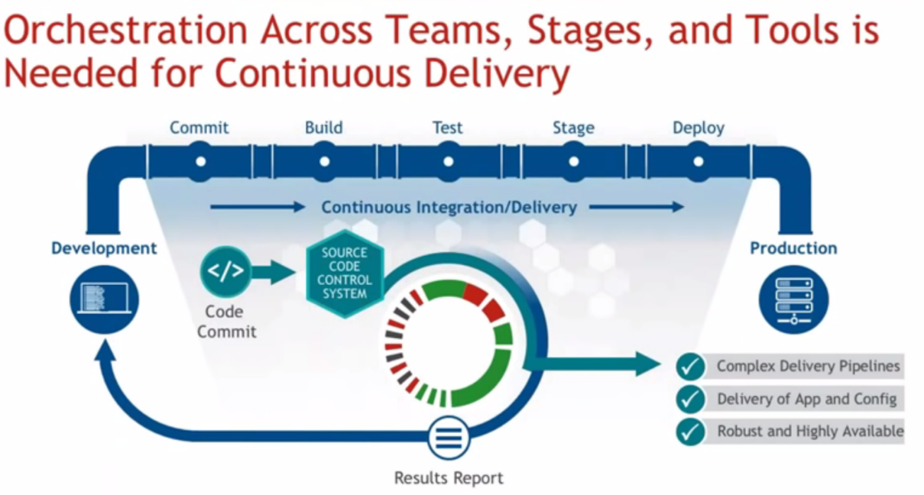

Tools used at different stages can be understood from below:

* Git/SVN
* Jenkins
* Maven
* SonarCube
* Docker
* Nexus
* Kubernetes

The CI/CD pipeline described above has the following steps/parts:

1. Developer pushes a commit to GitHub

2. GitHub notifies Jenkins of the update

3. Jenkins trigger the Build Job

4. Jenkins pulls the GitHub repository,

* It pulls the Docker file describing the image
* It pulls the application and test code.

1. Jenkins builds a Docker image on the Jenkins slave node and pushes it to DTR

* It instantiates the Docker container on the slave node, and executes the appropriate tests
* If the tests are successful the image is then pushed up to Docker Trusted registry(DTR)

1. If everything goes fine, Jenkins trigger for deployment
2. This triggers an image pull from DTR
3. Deploy the container to the environment

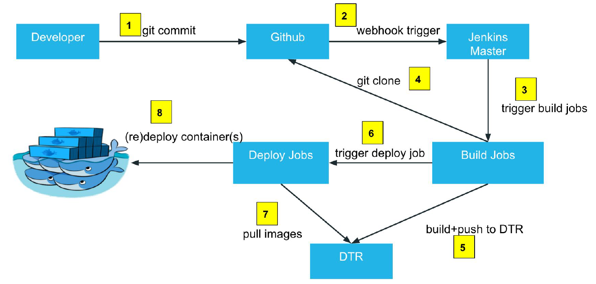

## 9.1 mS and Containerization using Docker

The application was run inside a VM. Container technology provides both speed for quick start (run time) of an application and reduces the footprint needed to run the application/component.

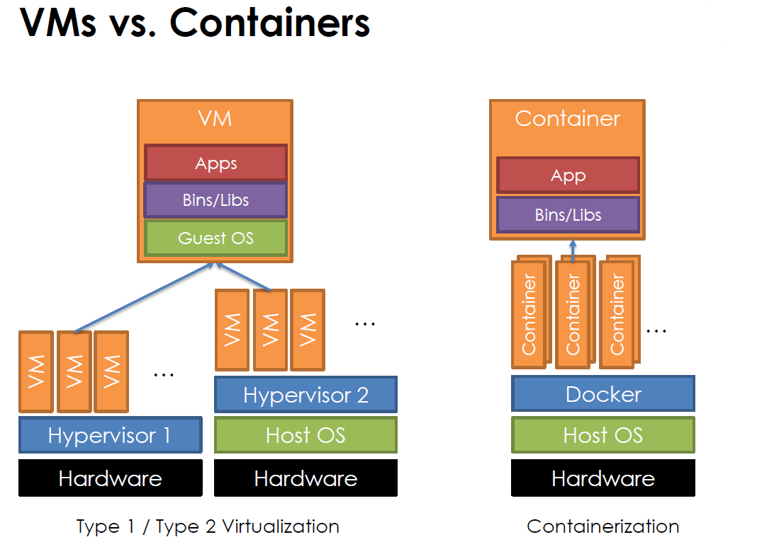

Below picture shows how ‘image’ is built and Docker is used for containerization of an application:

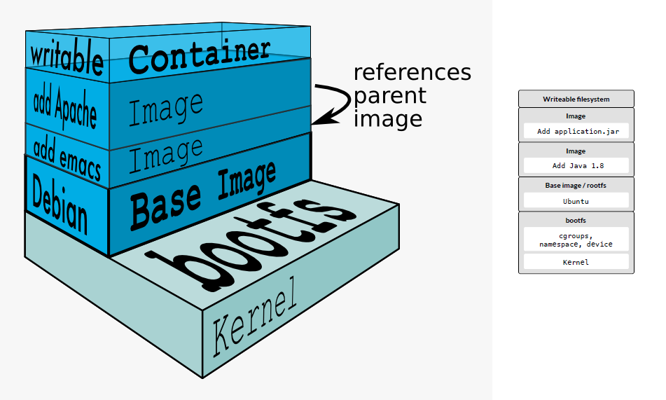

The CI/CD process pictured below automatically builds container out of a Docker file and eventually is deployed in production:

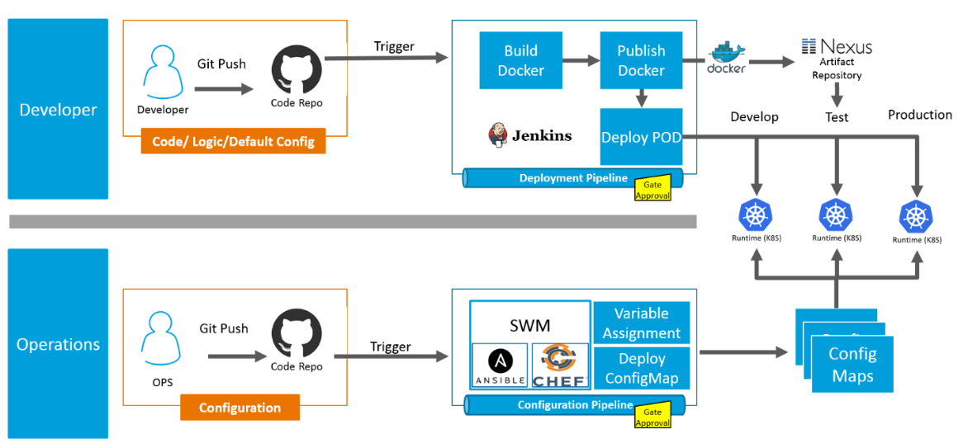

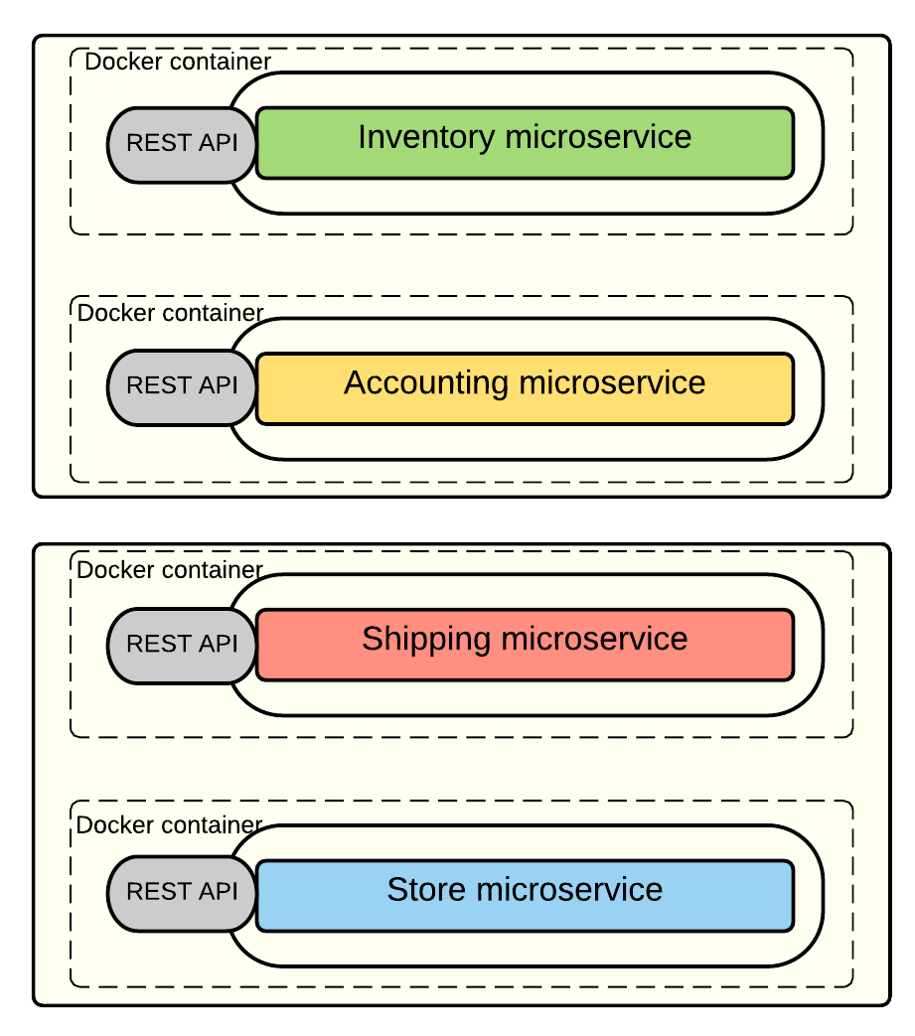

## 9.2 Container Management & Kubernetes

In an enterprise, there could be thousands of mS container running in a clustered environment. Monitoring and managing those instances can be managed with the ‘Kubernetes’ tool.

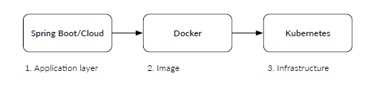

Terms associated with ‘Kubernetes’ is best described from the below picture:

* Containers runs as a cluster(vm/physical hardware)
* Containers works together as group which makes a pod.
* Services are Pods that work together
* Labels are used to organize services
* 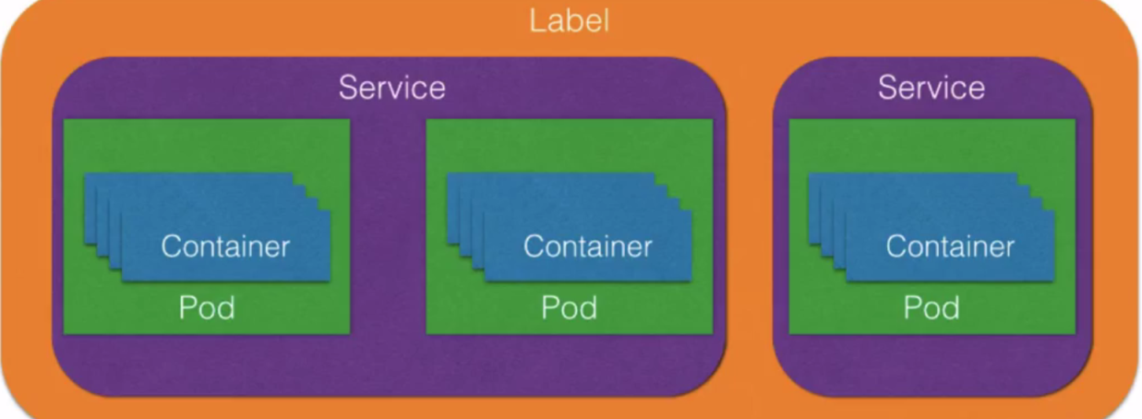

Kubernetes Master monitors container’s Nodes (Host)

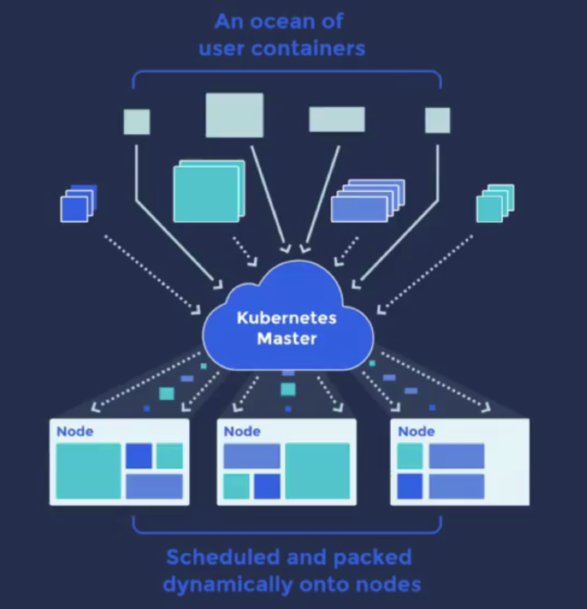

## Summary Steps for Build and Deploy

To summarize:

1) Create maven project from archetype

2) Run the spring boot service in eclipse and test from Postman

3) Build docker image using maven command in centos on VirtualBox

4) Run the docker image in centos on VirtualBox and test from Postman

5) Build and push docker image to docker registry (This step will take long time if done from VPN. This step is supposed to be done via jenkins build job)

6) Deploy the docker image from docker registry in K8S cluster and expose the service (This step will be automated via jenkins job)

7) Test the K8S deployed service from Postman

Framework team is working to make steps 3) and 4) optional once streamlined

Eventually, once the CICD pipeline tool matures and stabilizes, developers can utilize CICD and will only need to do steps 1), 2), 7)

# **10 Glossary**

# **Appendix-A (AJSC 6, Docker & K8S Resource Links)**

1. [Getting Started with Microservices](https://wiki.web.att.com/display/~sm6958/Getting+Started+with+Microservices):
   * [mS Basics & Environment](https://wiki.web.att.com/display/~sm6958/Getting+Started+with+Microservices)
2. mS Training:
   * [Training Curriculum](https://wiki.web.att.com/display/cdp/Training)
3. mS Policy Guide:
   * [mS Development Policy](https://tspace.web.att.com/files/app/file/7548a52d-dedb-42f5-9585-a72c428ad6f3)
4. Framework Tool Building mS:
   * [AJSC6 framework overview](https://tspace.web.att.com/communities/service/html/communityview?communityUuid=843bbb9f-ecbf-4552-9445-46b23879aaae#fullpageWidgetId=W435a559f5434_433b_90b2_511fe3f1fa77&file=98d8eb88-37e7-4854-8a9e-62f196268ef6)
5. Non-Modeled mS development Framework:
   * [AJSC6_NonM​odeled_Fra​mework-How to](https://tspace.web.att.com/communities/service/html/communityview?communityUuid=843bbb9f-ecbf-4552-9445-46b23879aaae#fullpageWidgetId=W435a559f5434_433b_90b2_511fe3f1fa77&file=13f647ac-6c84-456b-819c-9f421c7d10cb)
6. Migration Guide(Modelled and Non-Modelled):
   * [User Guide for migrating CSI M2E service to AJSC6 Modeled Soap or REST service](https://tspace.web.att.com/files/app/file/090859ba-c100-47a6-90d8-406b6341019e)
7. Modelled SOAP mS Developer Guide
   * [User Guide for creating a ajsc6 modeled soap service](https://tspace.web.att.com/communities/service/html/communityview?communityUuid=843bbb9f-ecbf-4552-9445-46b23879aaae#fullpageWidgetId=W435a559f5434_433b_90b2_511fe3f1fa77&file=0a4b8a63-4093-4910-9614-0bfbad630d3d)
8. Modelled REST Service Developer Guide:
   * [User Guide for creating a ajsc6 modeled rest service](https://tspace.web.att.com/communities/service/html/communityview?communityUuid=843bbb9f-ecbf-4552-9445-46b23879aaae#fullpageWidgetId=W435a559f5434_433b_90b2_511fe3f1fa77&file=e0c5ae5e-3533-4145-ba5a-951788664602)
9. mS Build Guide:
   * [Steps to create, build, push docker image and deploy to k8s](https://tspace.web.att.com/communities/service/html/communityview?communityUuid=843bbb9f-ecbf-4552-9445-46b23879aaae#fullpageWidgetId=W435a559f5434_433b_90b2_511fe3f1fa77&file=98b1fc21-b9b8-4eff-bc85-04bfbb0243f5)
10. mS Testing Automation
    * [mS Automated Testing Scope](https://tspace.web.att.com/communities/service/html/communityview?communityUuid=e201d6fc-7639-4e6a-835a-22b827e5e79e#fullpageWidgetId=Wd985fa766454_4dc6_9a2e_793cd673a6c8&file=e5af7eb6-5a4e-4c08-be92-ca86efccf526)
11. SRE mS Strategy
    * [Software Resiliency for mS development](https://tspace.web.att.com/communities/service/html/communityview?communityUuid=3554733d-7fab-4a9f-a990-27d1231e94e9#fullpageWidgetId=Wbb75fd38cf2f_4f0a_b6f2_a97235fedaa1&file=4e6eb9c6-b740-4374-a20b-adfe6d14c728)
12. REST Standard:
    * [REST Standard](https://wiki.web.att.com/display/ACSIDAandSA/REST+Policies+and+Standards) Document
13. SOAP Standard:
    * [SOAP Standard](https://tspace.web.att.com/files/app/file/5c2d5338-6e49-4d53-ab27-497ff733b15a) Document
14. TAM Naming
    * [TAM Details and Abbreviation](https://wiki.web.att.com/display/ACSIDAandSA/TAM+Conventions?preview=/600451696/615030773/TAM%20info.xlsx)

# **Appendix-B (Non-CDP-Pattern 5 / 6 mSs Integration Resources)**

For development teams implementing mS using the Minimally Viable Product for Pattern 5/6 in localized hosting developments, the following are integration resources:

1. Instruction to generate Keystore certificate : <https://wiki.web.att.com/pages/viewpage.action?pageId=560461321>
2. Instruction to configure Message Queues in AJSC : <https://wiki.web.att.com/pages/viewpage.action?spaceKey=ajsc&title=Pattern+6+for+AJSC+Service+project#Pattern6forAJSCServiceproject-MessageQueuesConfigurtion(QC)>
3. AAF Integration Wiki Page:

<https://wiki.web.att.com/display/ajsc/Cadi+-+AAF>

1. Pattern 5/6 Certification Activities: <https://wiki.web.att.com/pages/viewpage.action?pageId=492605117>